Edmodo: A Parent Guide to Getting Started

Parent accounts on Edmodo are a great way to stay informed of your child’s classroom activities, assignments, grades and school events. Before you can create a parent account, you must retrieve your parent code from your child’s Edmodo account (located on the right panel of their homepage) or from your child’s teacher.

How to Create a Parent Account

To create an account, visit Edmodo.com and select the “I’m a Parent Button” on the homepage, just below the student and teacher sign up buttons. Complete the registration form, which includes your unique parent code (provided by your child’s teacher), your relationship with the child and a valid email address.
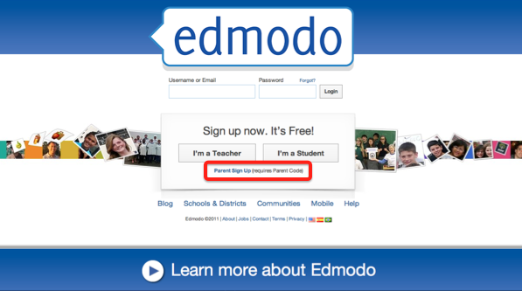

Account Overview

Within the parent account homepage, you can:
- View direct messages between your child and his/her teacher(s), as well as any messages the teacher has sent directly to the parent group
- View your child’s assignments, grades, calendar notices and assignment comments
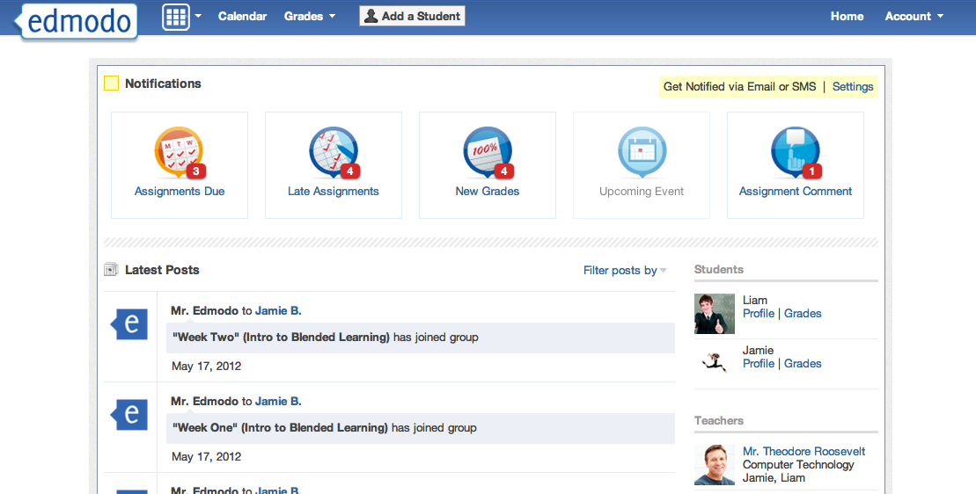
- Add additional children by clicking the “Add a Student” button from the top navigation bar
View messages from your child’s teacher
View assignments, grades and school notices

Add multiple children to one Edmodo account

Adjusting Account Settings

From the settings page, you can sign up for email or text notifications that will alert you to any assignments, direct messages or alerts from teachers. You can also change the email address and password associated with your Edmodo account.

To access the account settings page, select the down arrow located next to the “Account” option in the top navigation. In the drop down menu, select the “Settings” option.
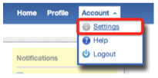
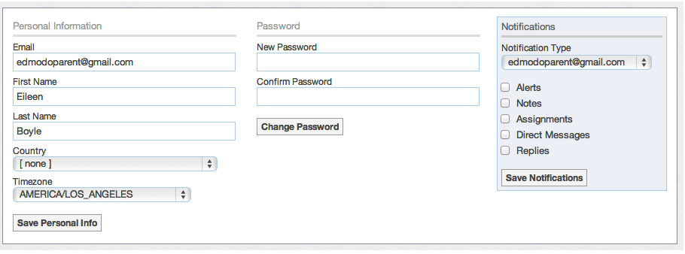

Turn on email or text message notifications.

Viewing Your Child’s Calendar

Within the calendar (located on the top navigation menu), you can see all of your child’s events, due dates, and assignments. If you have multiple children on Edmodo, you can filter to see a single child’s calendar by selecting their name from the drop down menu located at the top right corner of the calendar. To scroll through other months, select the forward and backward arrows in the upper left corner of the calendar.

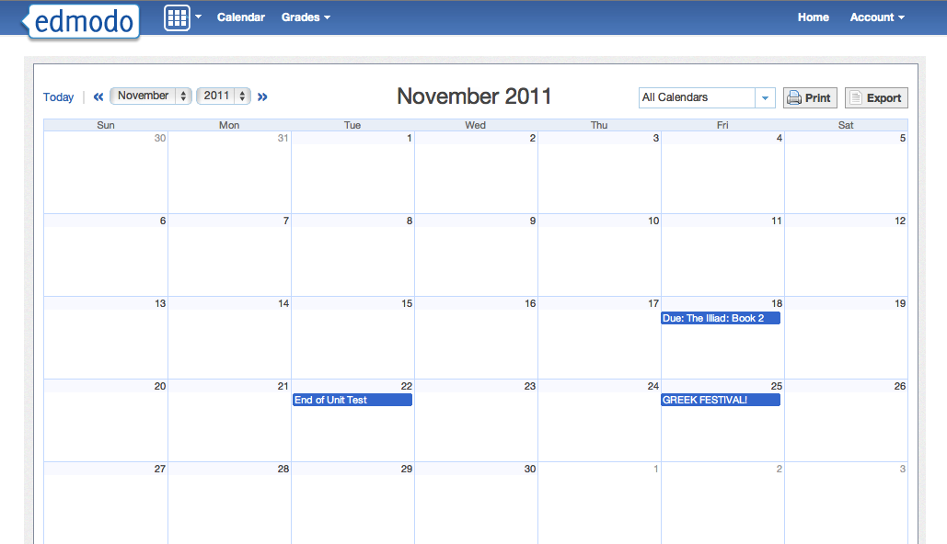

Filter by month or by student.

Viewing Your Child’s Grades

From the grades page, you can see all the assignments given to your child. You can filter between children and their groups from the left navigation panel.

Selecting the assignment title will bring you to the child’s assignment and allows you to view all comments between your child and his/her teacher.
Select any assignment to view it and review teacher comments

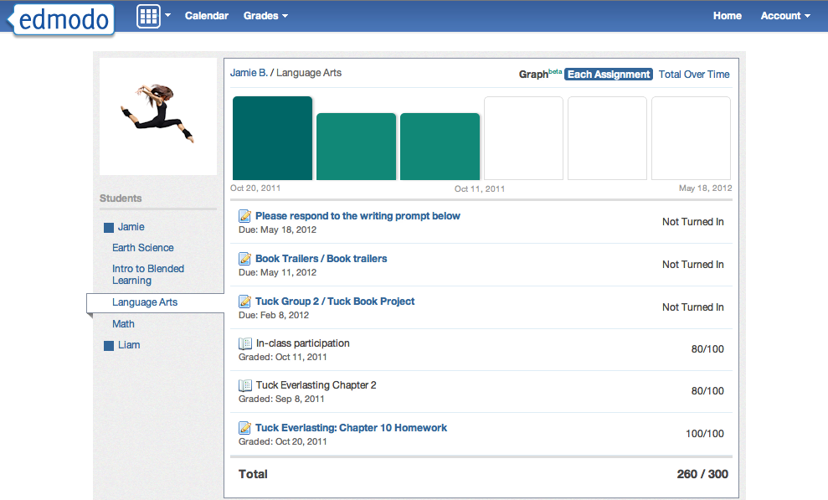
Filter by student and by group

