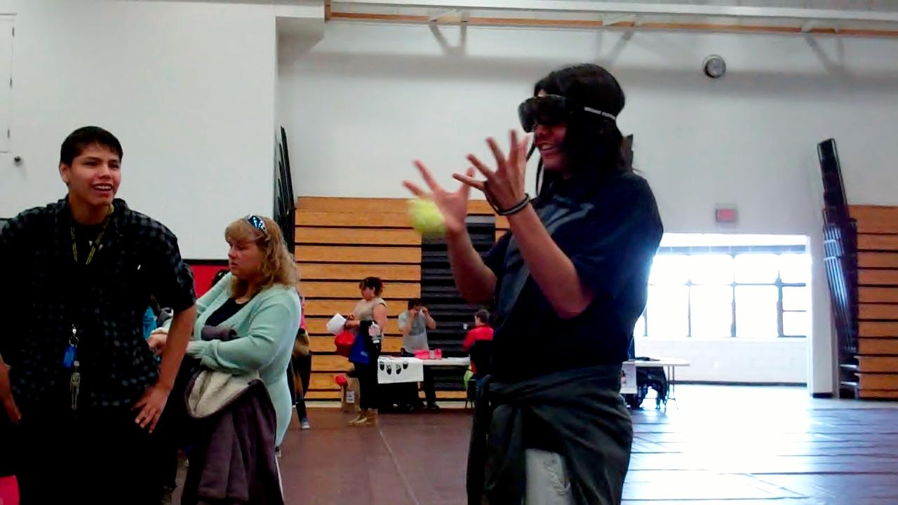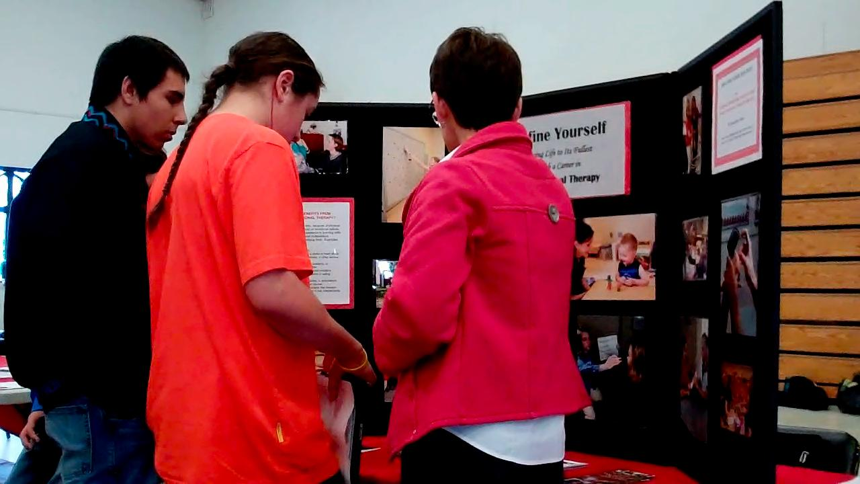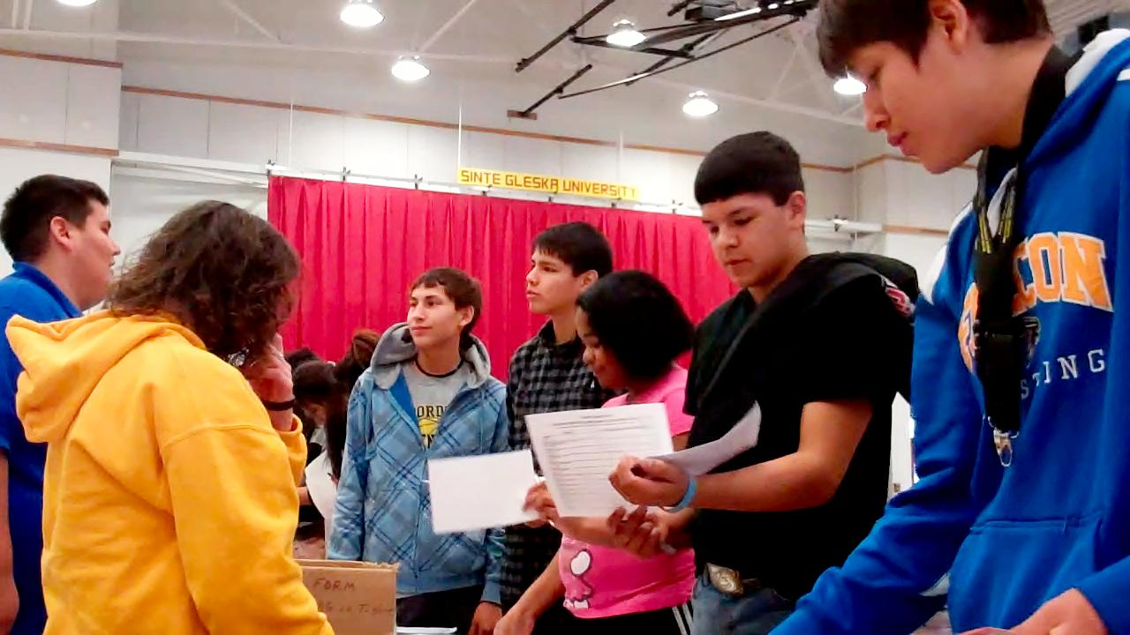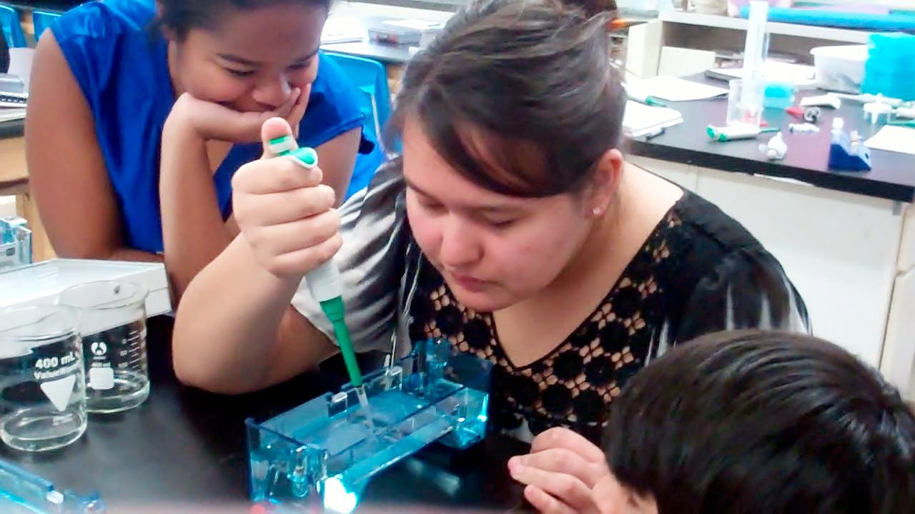**[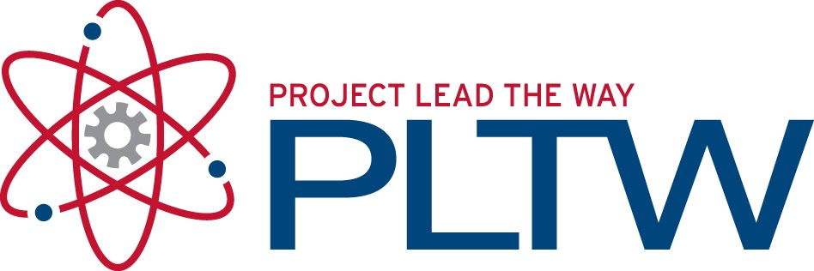](http://1.bp.blogspot.com/_IwrVxMXC70o/TGQDzOXeGzI/AAAAAAAAA2U/6TAzEaf3ywQ/s1600/PLTW.jpg)**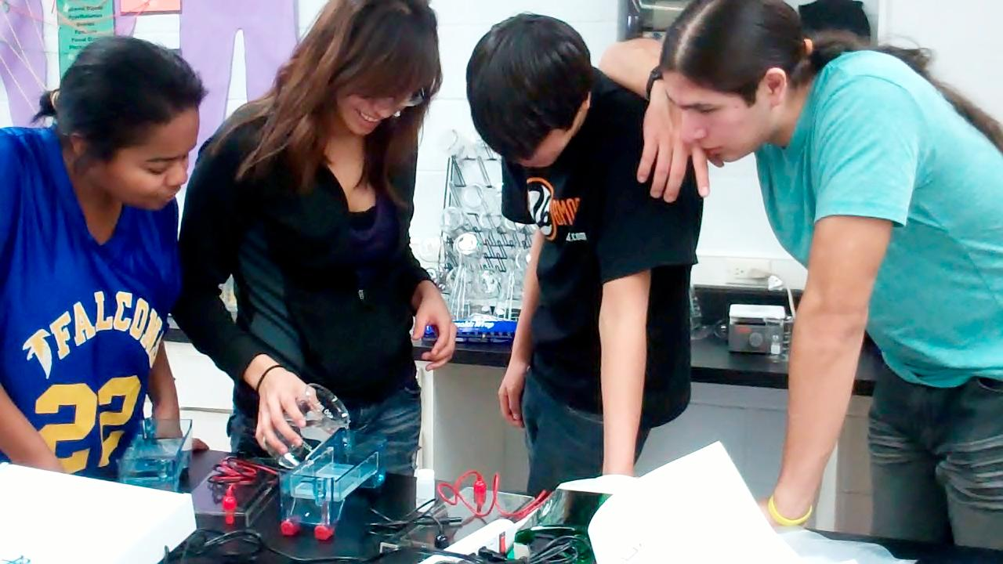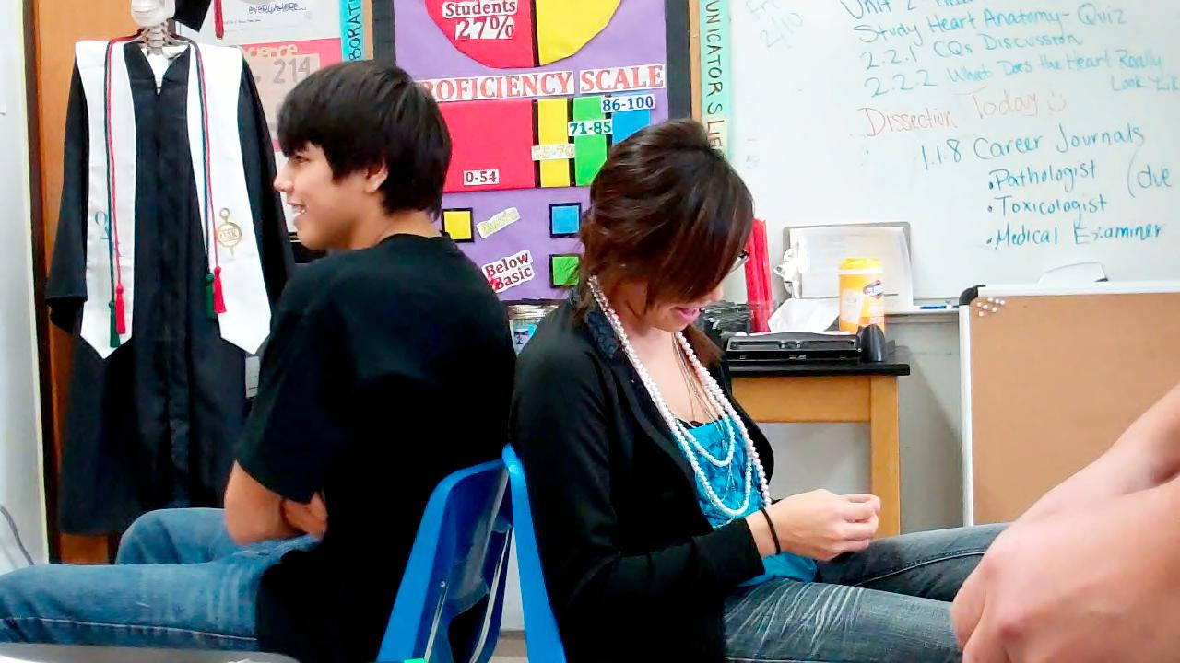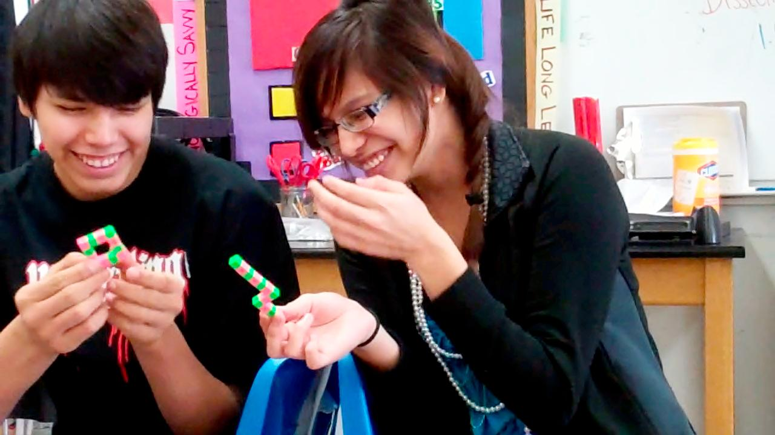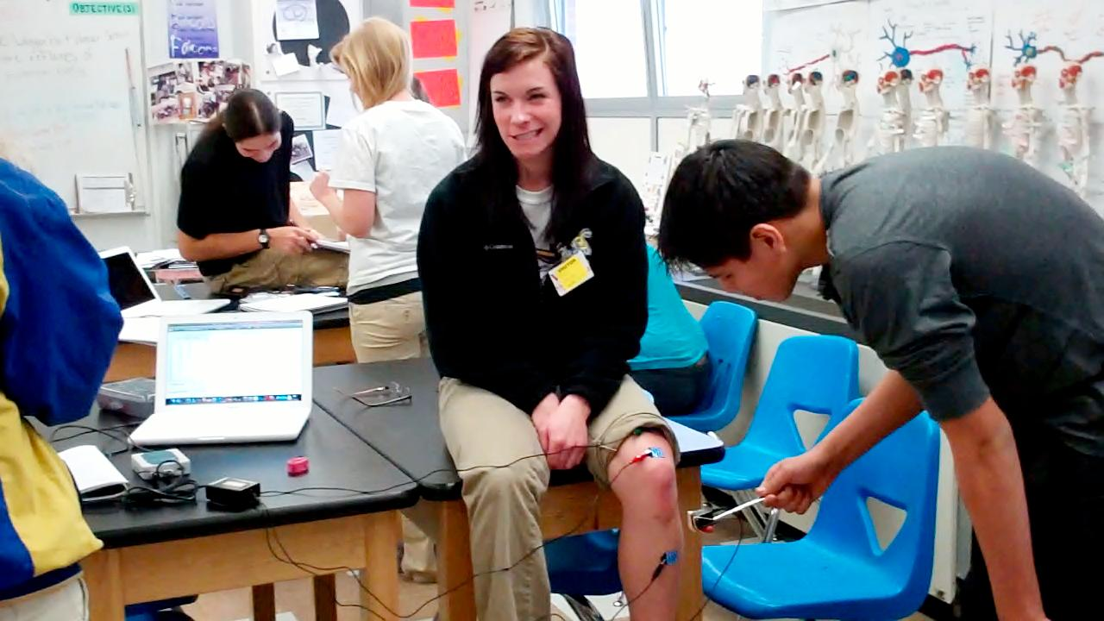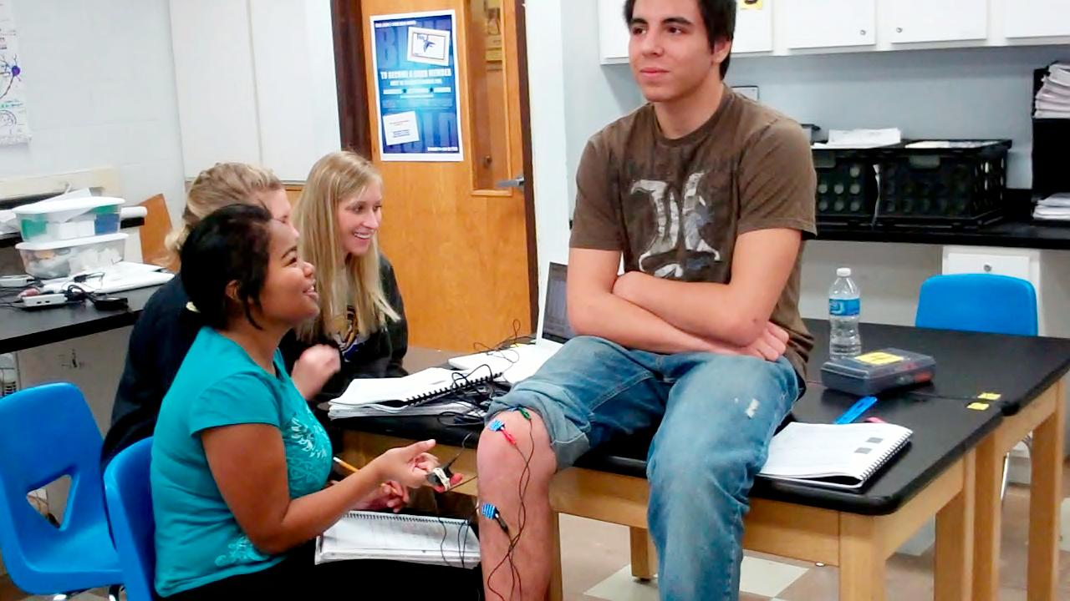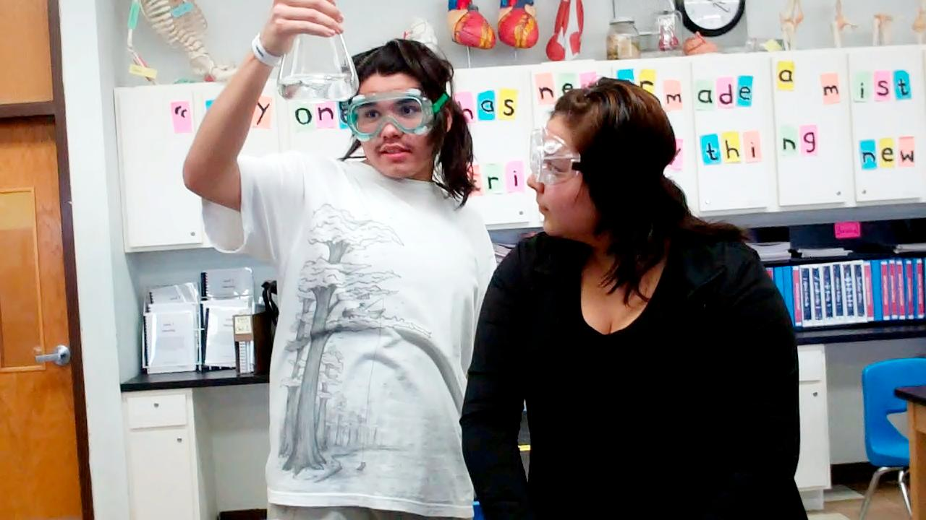

###### Look for more publications!

Feel free to contact me:

E-mail: mverroch@tcsdk12.org

Phone: (603) 986-7313

Website: <http://toddcountyhs.weebly.com/pltw.html> *(recently updated)

To contact

Ms. Verrochi

Students attended the 2nd Annual Healthcare Careers Day at SGU. The students had an opportunity to present and showcase their work. Students presented their brain maps, neuron models, manikens, and the communication game to a room full of middle school and high school students and healthcare professionals. They also got to learn about healthcare careers in the Rosebud community and summer and college opportunities. The students represented Todd County High School and PLTW proud!

## **Sinte Gleska University**

## **Multipurpose Building**

## **March 7th, 10am-2pm**

# 2nd Annual Healthcare Careers Day

Last month students worked as Forensic Anthropologists and DNA Analysts. Above students are performing Gel Electrophoresis in order to make DNA fingerprints. They have been working at matching bones of two fictitious persons found in the park to fictitious missing person reports from the police department. Congratulate your students on performing a college-level lab!

Volume 2 February/March 2012

**HUMAN BODY SYSTEMS**

**pg.1**

Ms. Verrochi’s Class Newsletter

On February 28th, SDSU nursing students came to TCHS to work with our students. This is a new group of students led by the same instructor who invited us to attend SDSU last fall to see the campus, anatomy lab, and patient simulators. The nursing students helped us complete a reflex lab, testing the difference between voluntary and involuntary responses with EKG sensors and computers. Above the students are testing the patellar reflex on one another.

Students have been working on Unit 2 Communication, learning all about the nervous and endocrine systems. They have made maps of their brains on swim caps, neuron models with clay, and sculpted brains in their manikens. Next week we will be learning about the senses by dissecting the eyeball and learning about vision. In the near future students will be taking a field trip to the Wright Vision Center in Rapid City to watch eye surgeries and apply their knowledge from class to a real-life healthcare profession. The unit 2 test will be scheduled for next week. It covers a lot of information so encourage your students to study.

#### SDSU Nursing Students Visit Our Classroom.

In order to keep all students on track to earning college credit we have created a Wall of Fame for students who have scored an 80% or higher on their Unit Assessments. Remember, students can earn three biology college credits if they earn an 80% or better on the End-of-Course Assessment (ECA).

Students took the Unit 1 Identity Assessment on February 8th. The following students were recognized on the Wall of Fame.

Our class goal is to have ALL students earn college credit for Human Body Systems. Please continue to encourage your student to study and prepare for the course.

**Congratulations to Mikiyela Colombe, Tanner Colombe, Samira Jones, Lottie Grimshaw, Hehaka Nunpa, Bethany Wilkie for earning college an 80% or higher on their Unit 1 Assessment.**

Don’t forget to apply for a summer science opportunity such as INMED or Health Careers Camp. Deadlines are fast approaching!

**Tracking Progress Towards College Credit**

**Bailey and Mercedes playing a communication game.**

**cont.**

This week students have been measuring vital signs of the heart

Justo id eleifend faucibus, urna dolor consectetuer dui, vel pretium risus purus sed pede. Integer diam elit, facilisis eget.

Donec varius, felis eget lobortis vehicula, magna sapien elementum tellus, ut iaculis dui orci sed arcu. Nullam semper leo.