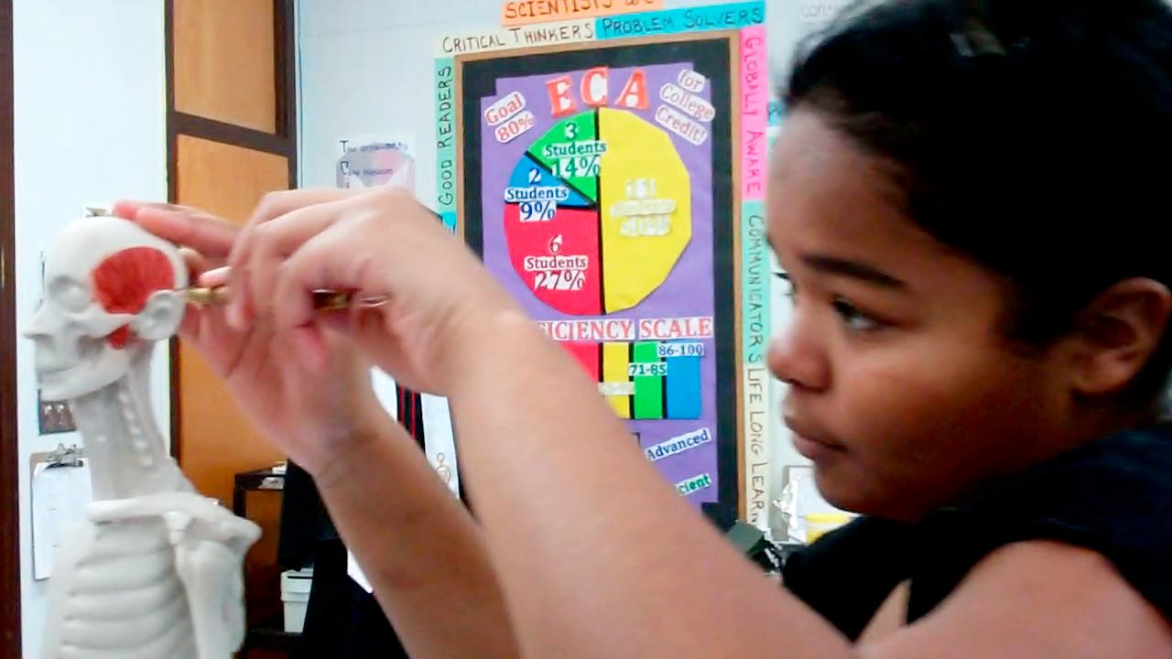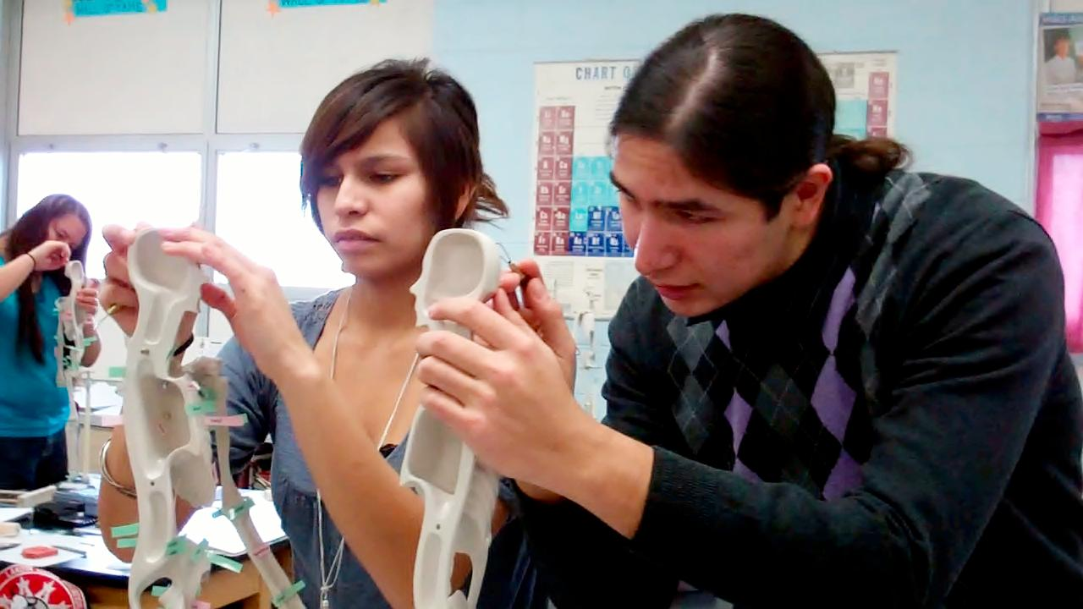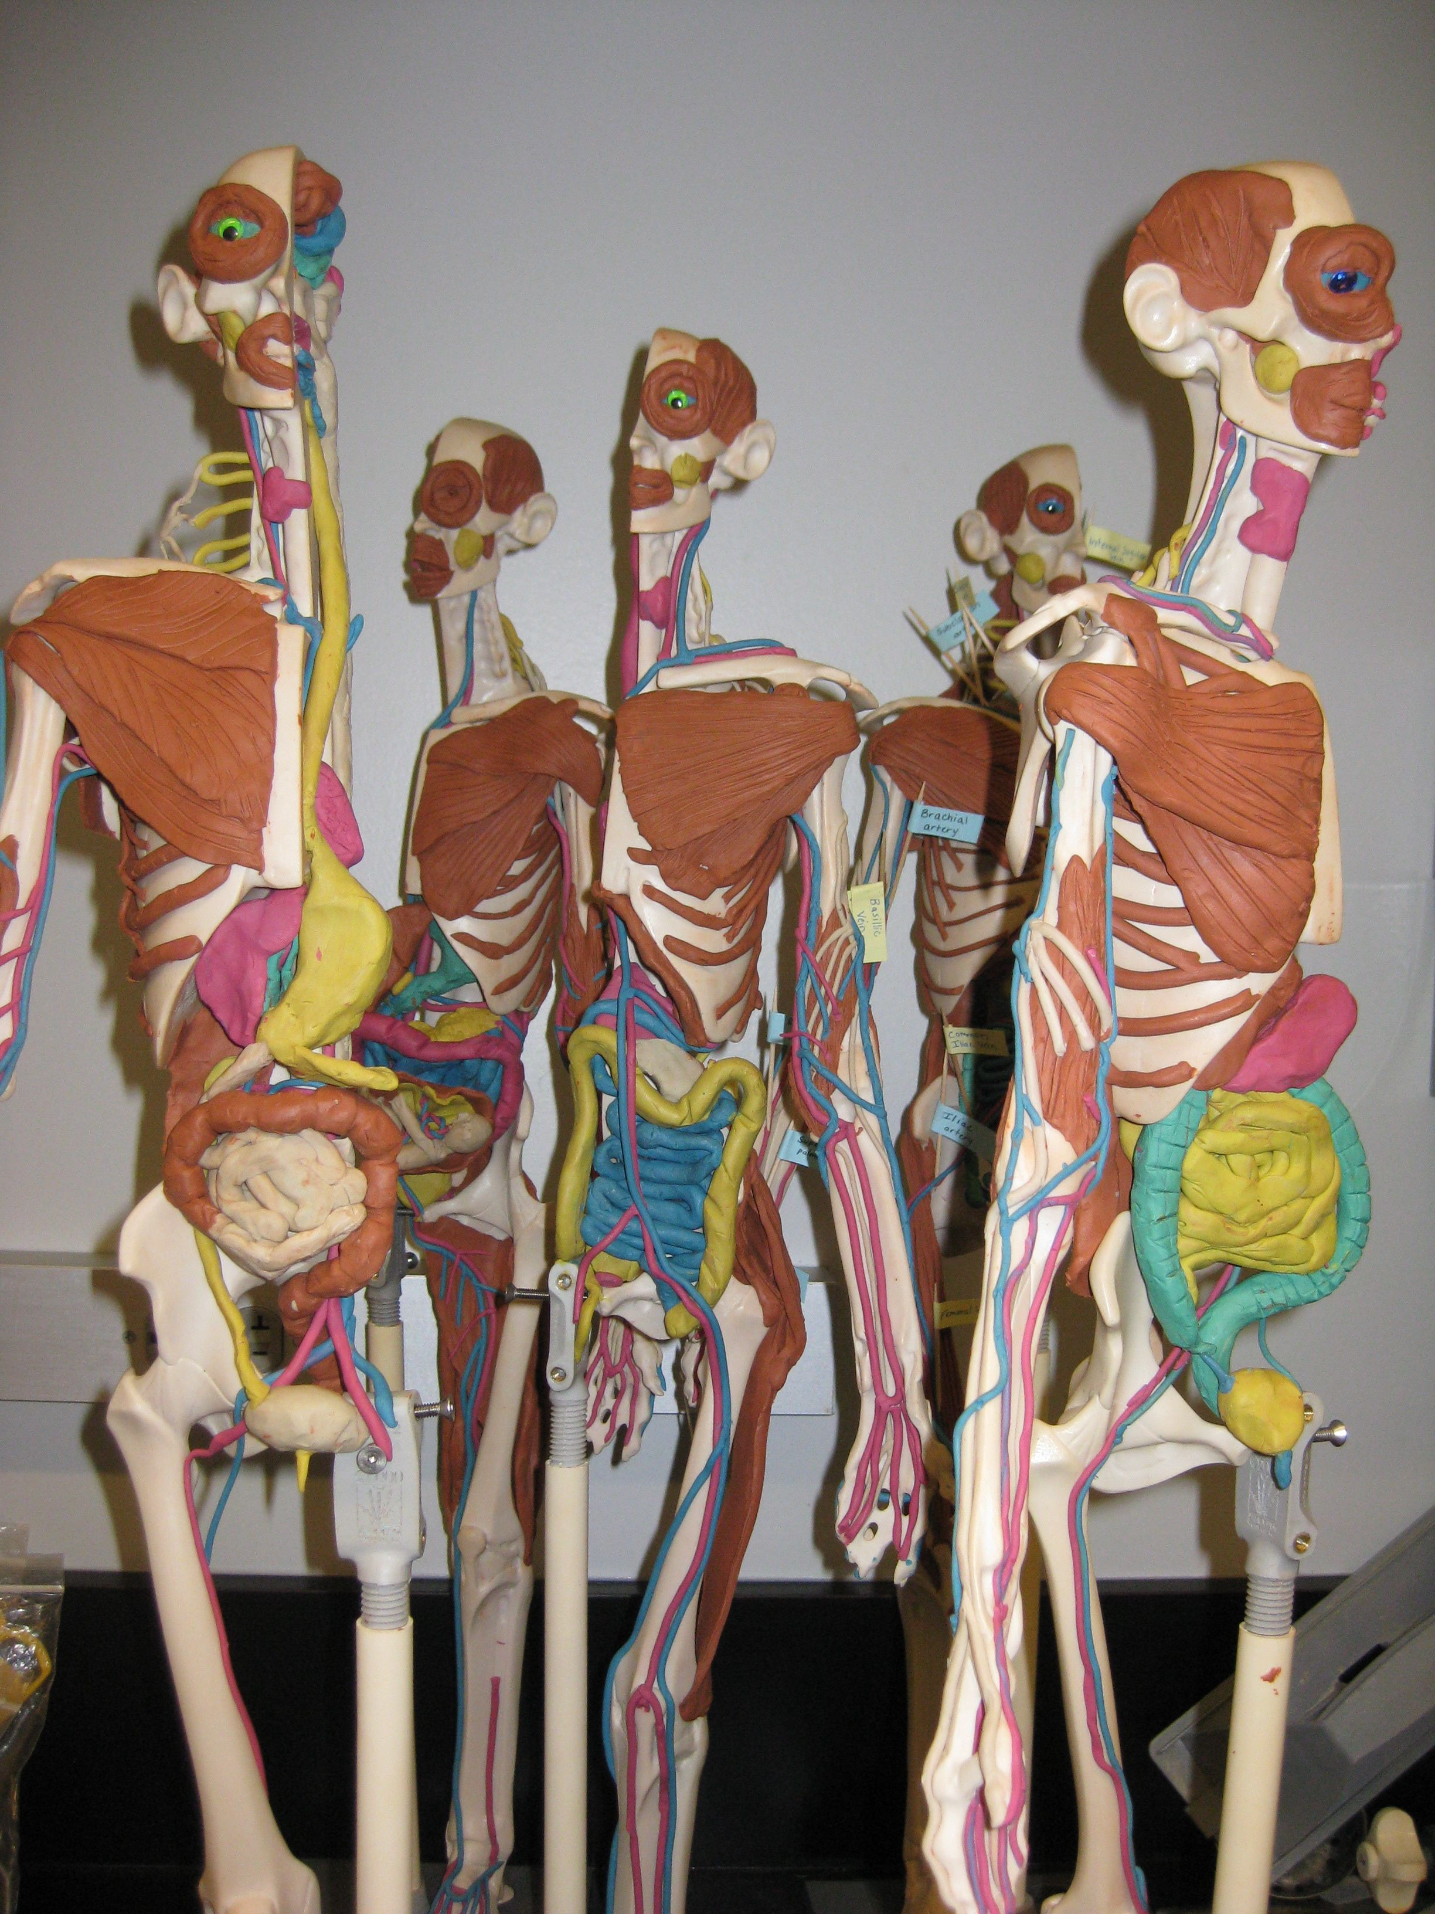**[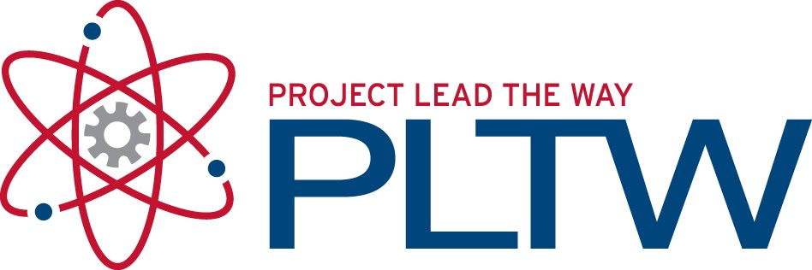](http://1.bp.blogspot.com/_IwrVxMXC70o/TGQDzOXeGzI/AAAAAAAAA2U/6TAzEaf3ywQ/s1600/PLTW.jpg)**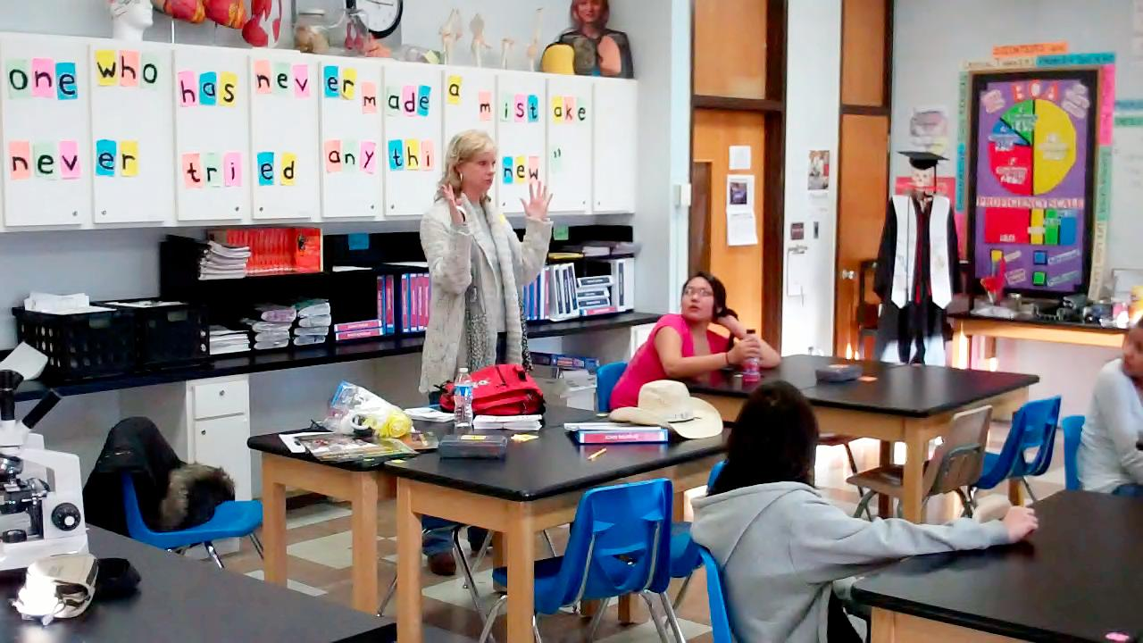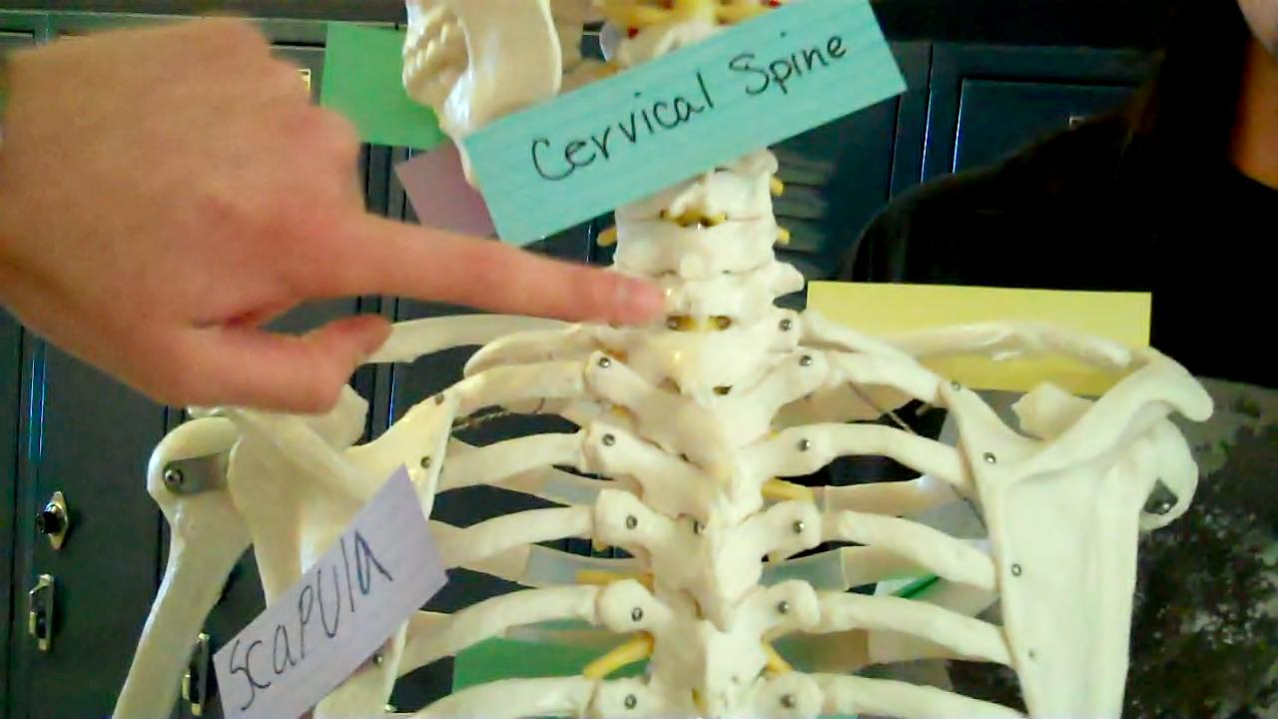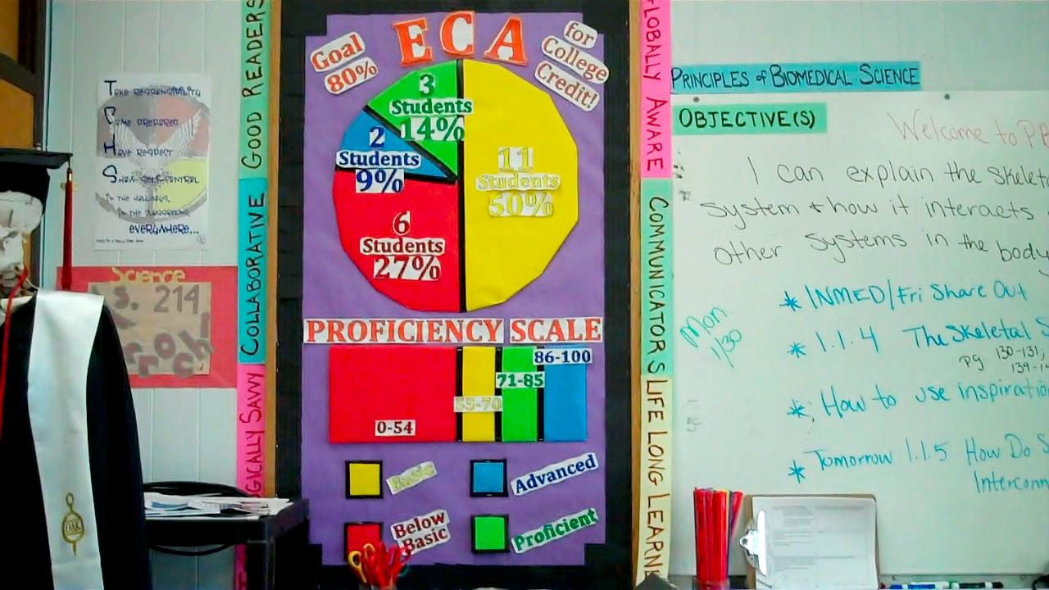

Volume 1 January 2012

Welcome to the second course of Project Lead The Way. The Human Body Systems course examines the interactions of human body systems that maintain health. This will be a fun, engaging, and challenging course that will help students prepare for college level science and biomedical careers.

Throughout the Humans Body Systems course, students will model human anatomy and explore human physiology on their own 2 foot skeletal Maniken. They will build muscles, create blood vessels and nerves, and sculpt many body organs including the heart and brain. Over the course the semester students will make their Manikens come alive with clay organs and tissues.

## **Students learn Anatomy and Physiology in HBS working with Manikens ®**

Feel free to contact me:

E-mail: mverroch@tcsdk12.org

Phone: (603) 986-7313

Website: http://toddcountyhs.weebly.com/pltw.html

# ANATOMY IN CLAY

To contact

Ms. Verrochi

**HUMAN BODY SYSTEMS**

###### Look for more publications!

**pg.1**

Ms. Verrochi’s Class Newsletter

**Kathy VanKley speak about the summer opportunity INMED**

Kathy VanKley visited the class on January 27, 2012 and spoke s about summer opportunities. I encourage all students to apply for one summer experience:

* INMED – Indians Into Medicine June 11-July 20th, 2012 @ University of North Dakota Application available at *www.med.und.edu/.../updated-****2012summer****-insitute-editable.pdf* (deadline is March 31st)
* Health Careers Camp – June 17-22, 2012 @ University of South Dakota. Application available at www.usd.edu/med/health-careers-camp.cfm (deadline is April 30th)

Over the past week in class students have been learning directional and regional terminology. Students have also learned the bones of the body and skull and three muscles of the face. They will work in small groups to create videos that teach these terms to others. You can find the videos displayed on our website http://toddcountyhs.weebly.com/pltw.html

Challenge your student by asking them to teach you the terms they have learned so far.

Next week we will be working as bone detectives becoming forensic anthropologists.

#### Students Learn Terminology of the Human Body

Just as with Principles of Biomedical Sciences, students enrolled in this course will have the opportunity to earn three biology college credits if they earn an 80% or better on the End-of-Course Assessment (ECA). The assessment will be administered late April/early May.

To the right you can see the ECA class results from PBS. Two students earned advanced, three earned proficient, eleven earned basic, and six below basic. Our class goal to have ALL students earn an 80% or higher to walk away with college credit ☺ You can help by encouraging students to study their terminology and stay on top of their classwork.

**Congratulations to Tanner Colombe, Lottie Grimshaw, Jaycob Herman, Samira Jones, and Austin Schmitz for earning college credit for Principles of Biomedical Sciences.**

**EARN COLLEGE CREDIT!**

**cont.**

This week students have been measuring vital signs of the heart

Justo id eleifend faucibus, urna dolor consectetuer dui, vel pretium risus purus sed pede. Integer diam elit, facilisis eget.

Donec varius, felis eget lobortis vehicula, magna sapien elementum tellus, ut iaculis dui orci sed arcu. Nullam semper leo.