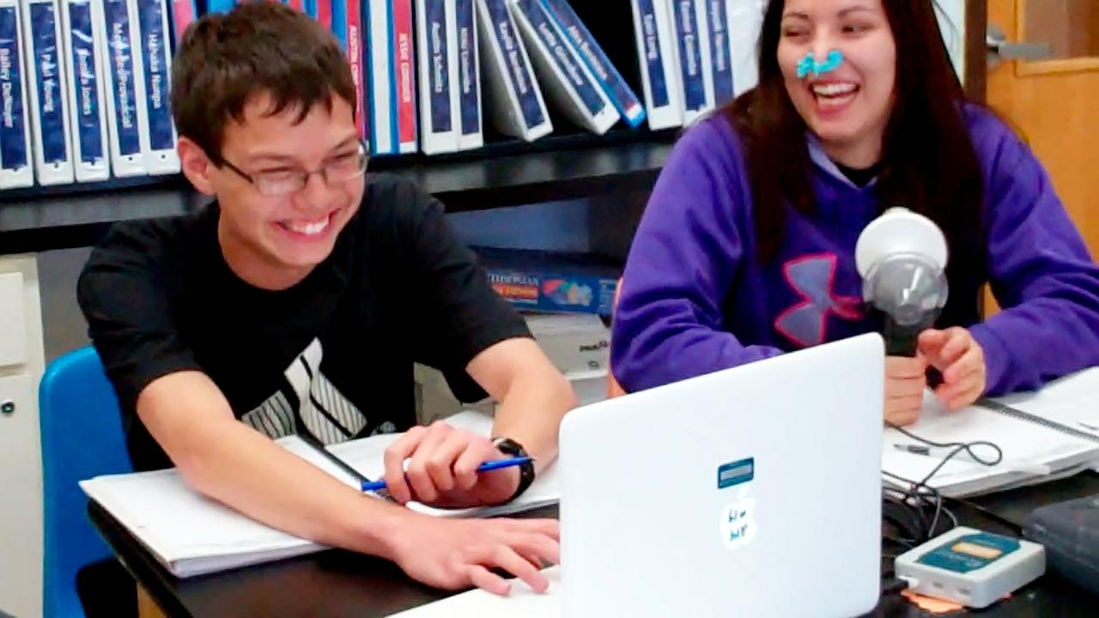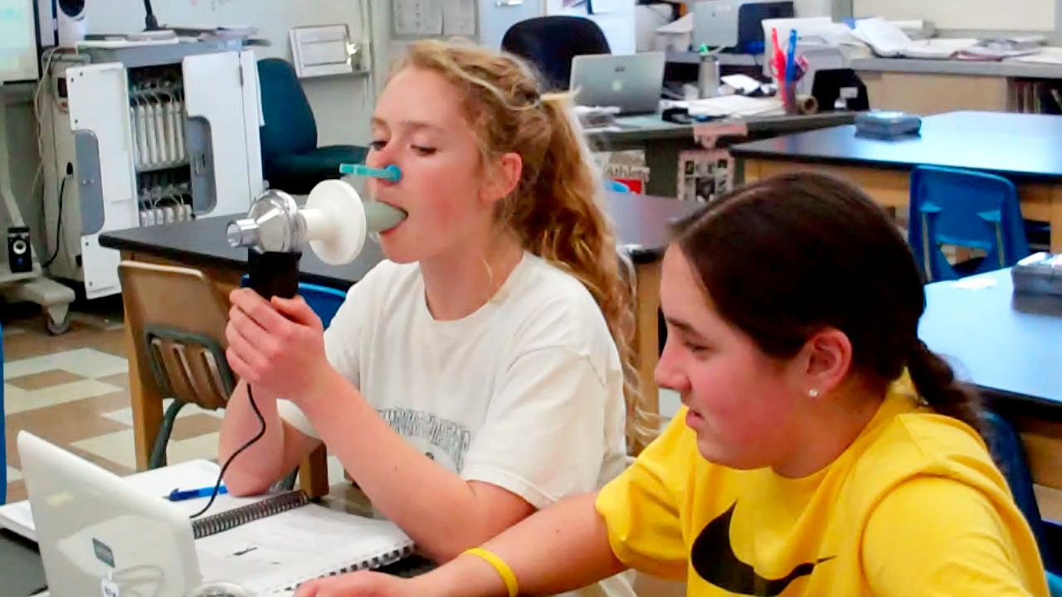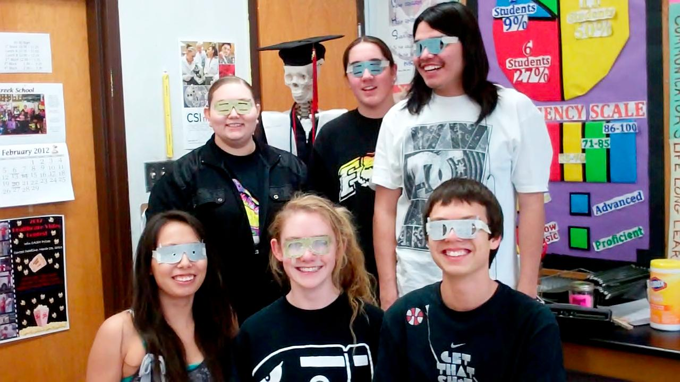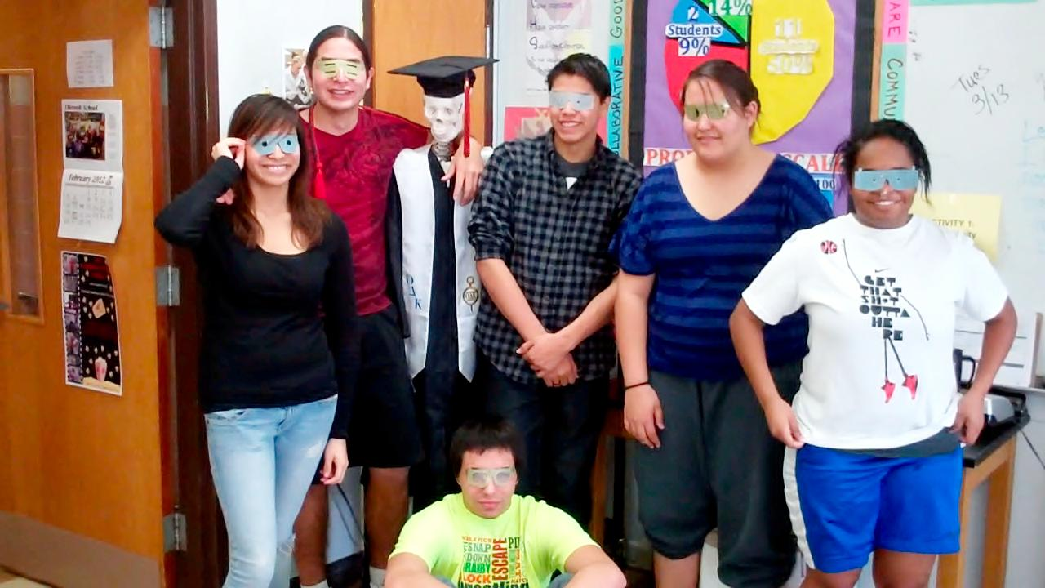**[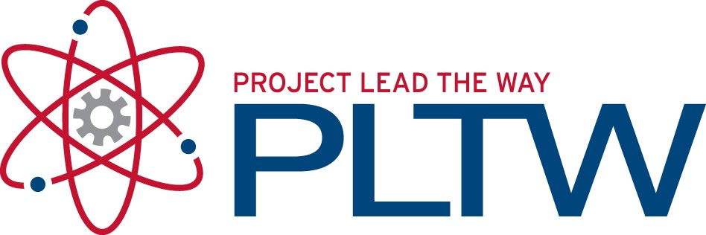](http://1.bp.blogspot.com/_IwrVxMXC70o/TGQDzOXeGzI/AAAAAAAAA2U/6TAzEaf3ywQ/s1600/PLTW.jpg)**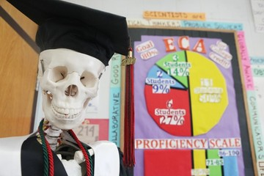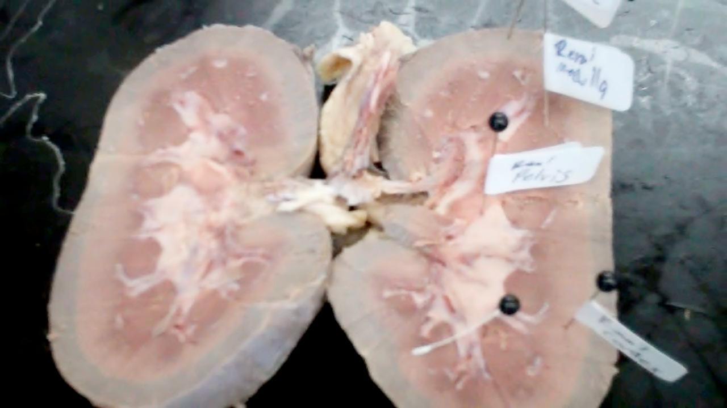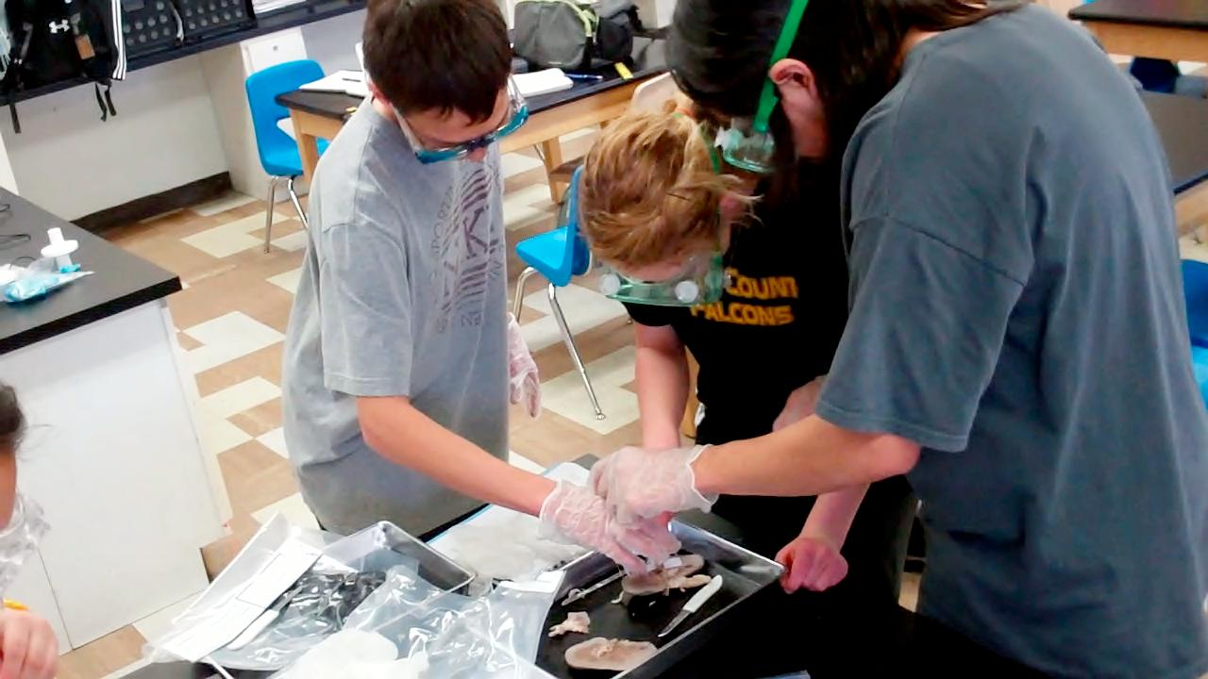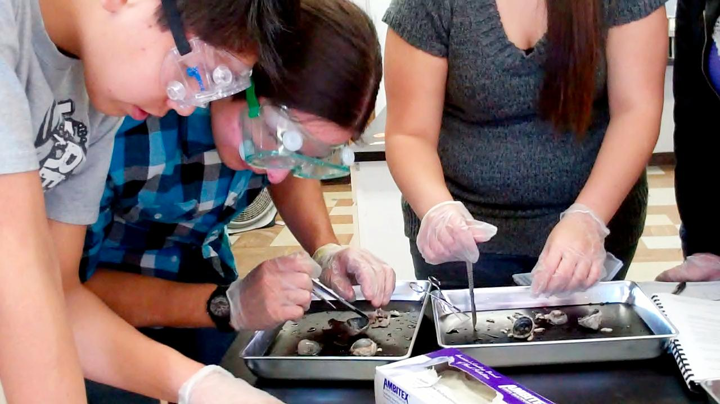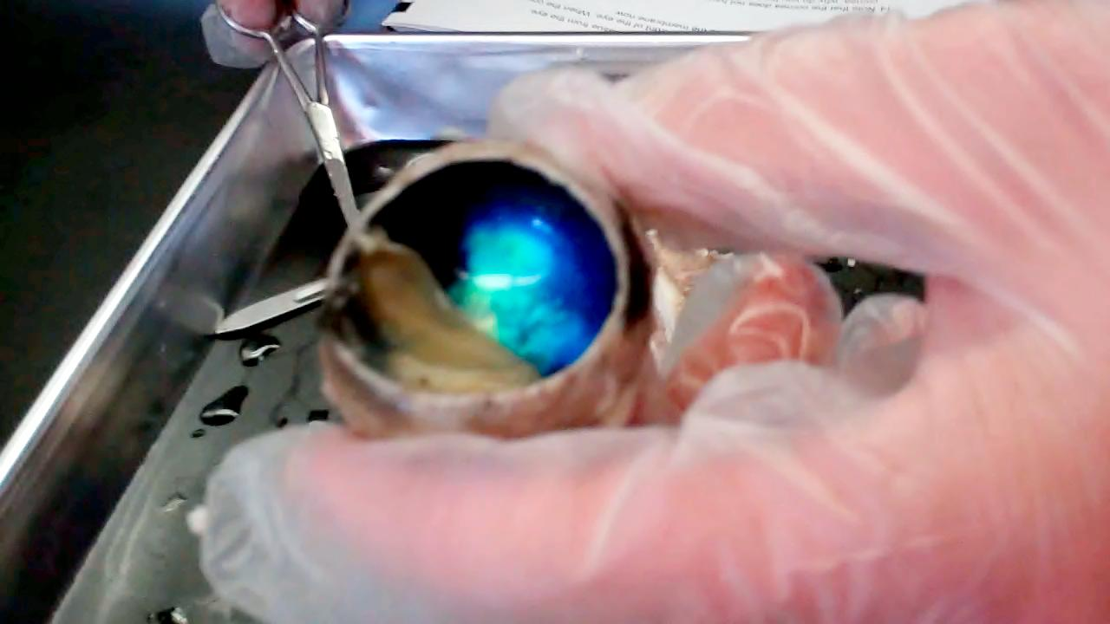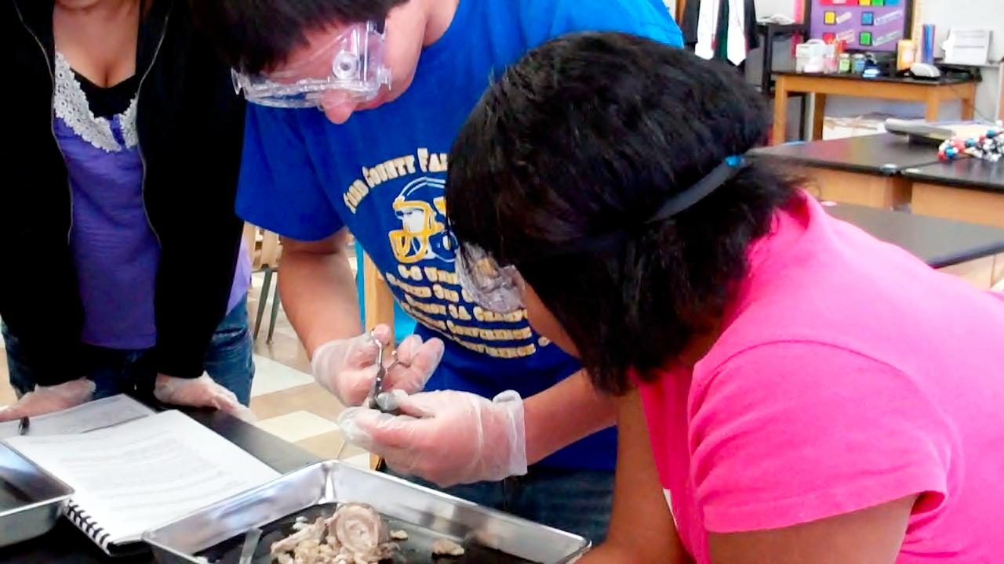

## **Students head to Wright Vision Center to work with**

## **Dr. Cris Mathews**

# Observing Eye Surgery

*“Visiting the eye clinic was very exciting. I really enjoyed how nice the staff was. They were super excited to have us and they totally let us have the greatest experience”* –Samira Jones

Two groups of six students traveled to Rapid City on March 27th, 2012 and April 3rd, 2012 to visit the Wright Vision Center. Students have been learning all about the anatomy and physiology of the human eye and this field trip was a chance to apply what we learned in class to medical careers. In addition to learning about health careers pertaining to the eye, students got the opportunity to shadow cataracts surgery, observe patient care during pre- and post-op and look at each other’s optic nerves, iris, and other internal structures of the eye using various cameras, scopes, and technologies.

Block 4

Kaylie

Tanner

Jaycob

Miki

Lottie

Austin

Block 2

Mercedes

Hehaka

Bailey

Sam

Bethany

Paul

Students are wearing visual impairment glasses: these glasses portrayed how vision would be affected if you had a detached retina, cataracts, glaucoma, and other eye disorders.

###### Look for more publications!

Volume 3 March 2012

Ms. Verrochi’s Class Newsletter

**HUMAN BODY SYSTEMS**

In this unit students investigate how the body obtains, distributes, or processes the body's primary resources for energy and power - food, oxygen, and water.  They learn about the digestive system, respiratory system, and urinary systems.  Above, students use Spirometers to measure their lung capacities.

Feel free to contact me:

E-mail: mverroch@tcsdk12.org

Phone: (603) 986-7313

Website: <http://toddcountyhs.weebly.com/pltw.html>

To contact

Ms. Verrochi

**pg.1**

**Tracking Progress Towards College Credit**

The End of Course Assessment (ECA) is coming up at the end of April/early May. This is the chance where students get to demonstrate what they have learned in the course in order to earn college credit. Students should begin preparing for this assessment NOW. You can help at home by encouraging students to go on the class website and review anchor charts from previous units and reading over their notebook assignments.

Before Easter break, students will take their unit three assessment on Power. Studying for this exam will help students be ready for the ECA. Students should feel confident in understanding the anatomy and physiology of the digestive, respiratory, and urinary systems for this assessment.

**Next unit is called Movement. Here students will build muscle groups on their Manikens and learn how a muscle’s structure is directly related to its function and to the actions it can produce.**

Learning essential lab and cooperation skills will prepare students for college!

Your eye has the amazing ability to convert light into a stream of nervous impulses. Students dissected a cow’s eye to figure out the specific function of each part of the eye.

**cont.**

#### Pig Kidney Dissection

#### Cow Eyeball Dissection

One way to see how something works is to look inside it. In the past few weeks, students have been utilizing their dissection skills in order to observe the internal structures of the eye and the kidney in order to learn how they function.

Students worked in teams to dissect and label the structures of the kidney and to investigate the location of nephrons, the specialized cells in the kidney that produce urine.

This week students have been measuring vital signs of the heart

Justo id eleifend faucibus, urna dolor consectetuer dui, vel pretium risus purus sed pede. Integer diam elit, facilisis eget.

Donec varius, felis eget lobortis vehicula, magna sapien elementum tellus, ut iaculis dui orci sed arcu. Nullam semper leo.