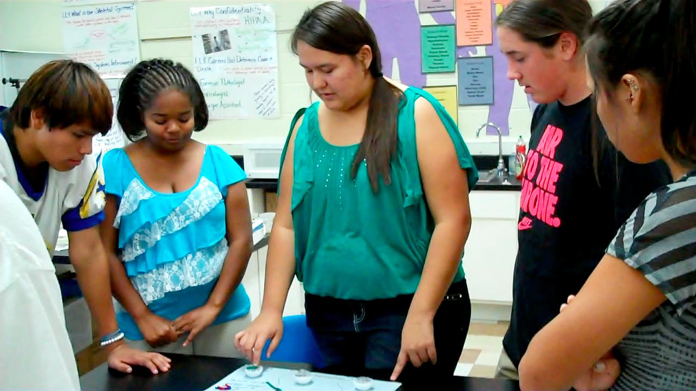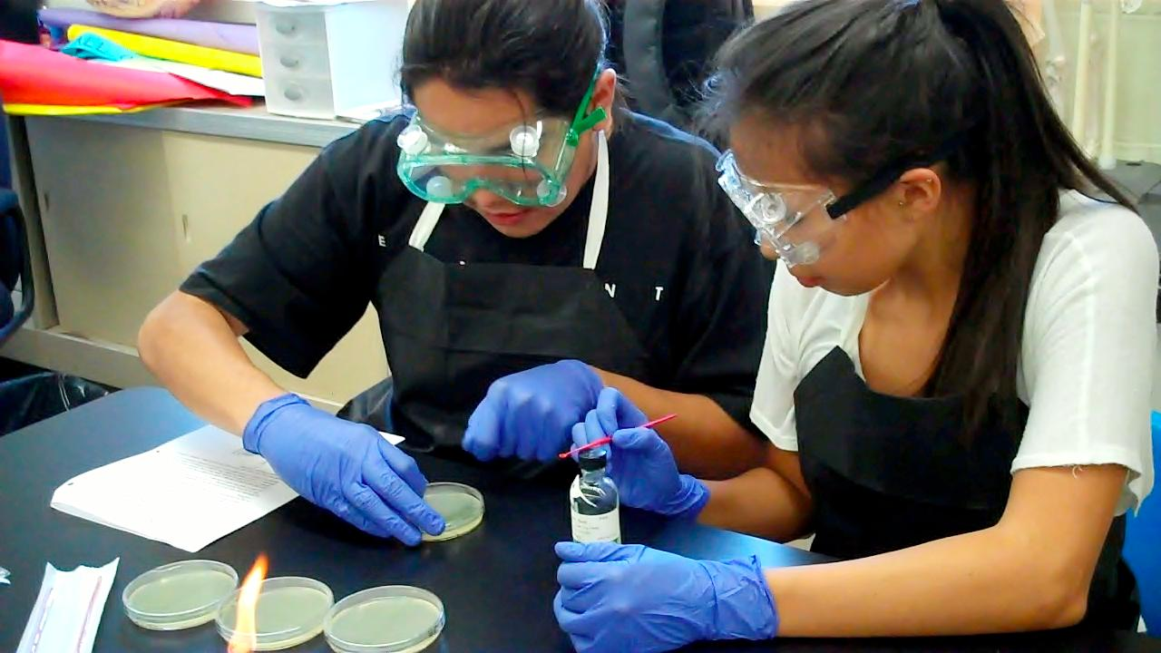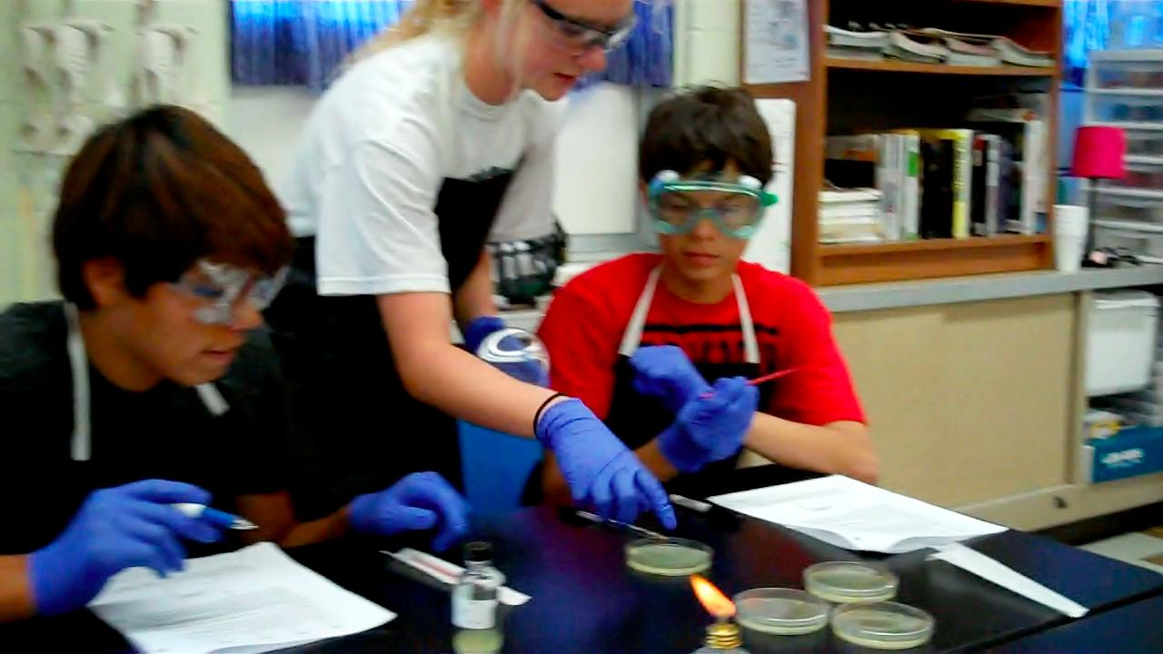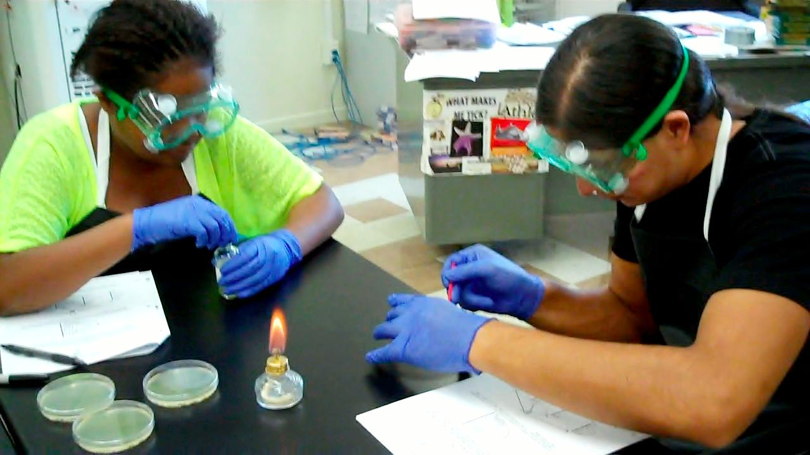**[](http://1.bp.blogspot.com/_IwrVxMXC70o/TGQDzOXeGzI/AAAAAAAAA2U/6TAzEaf3ywQ/s1600/PLTW.jpg)**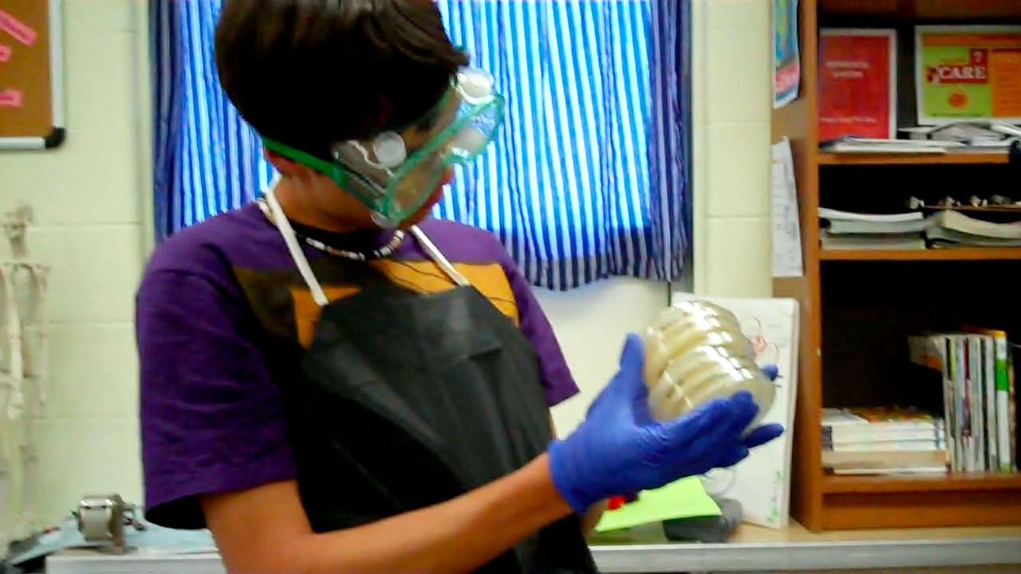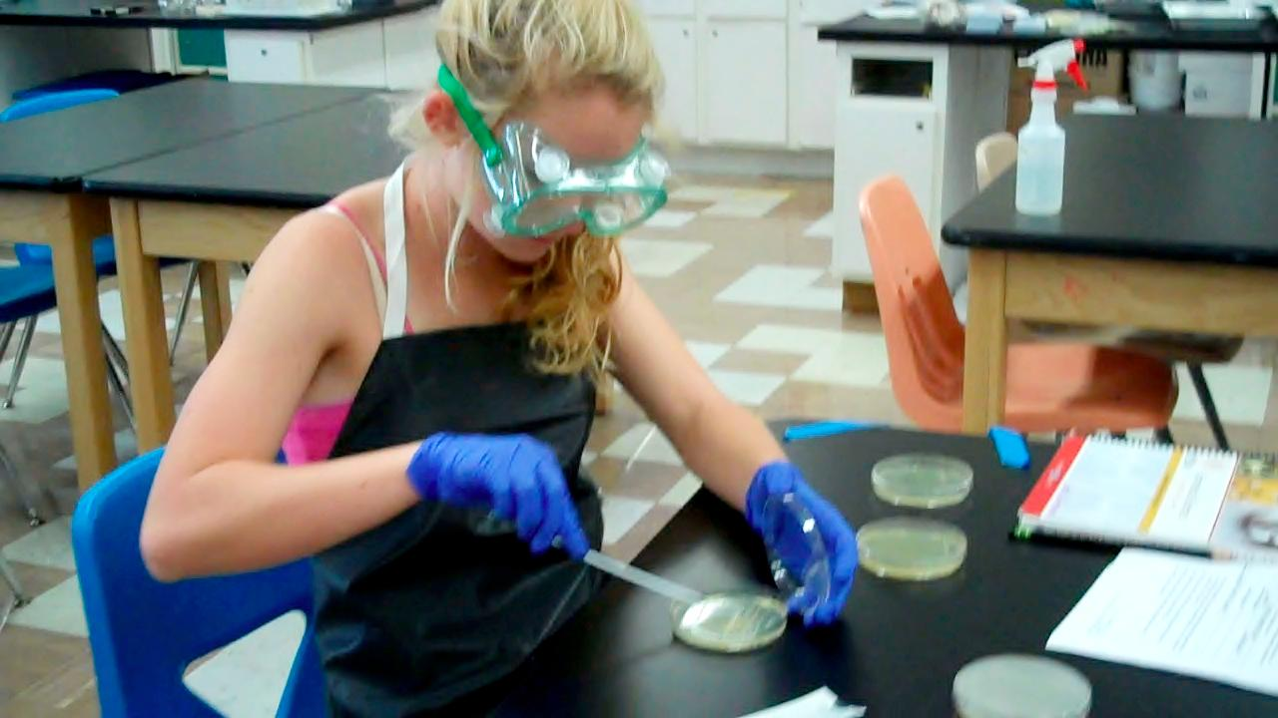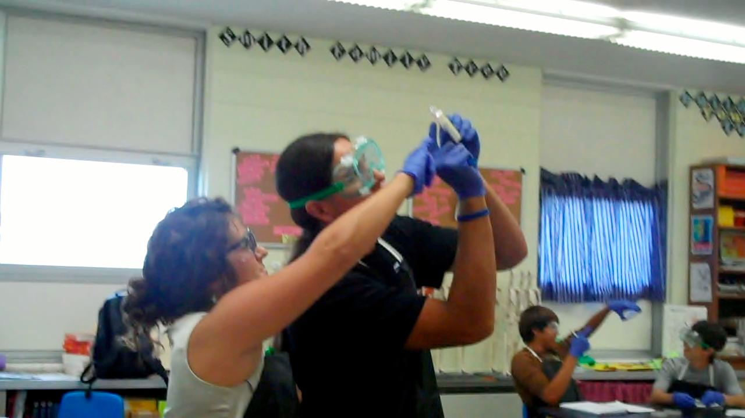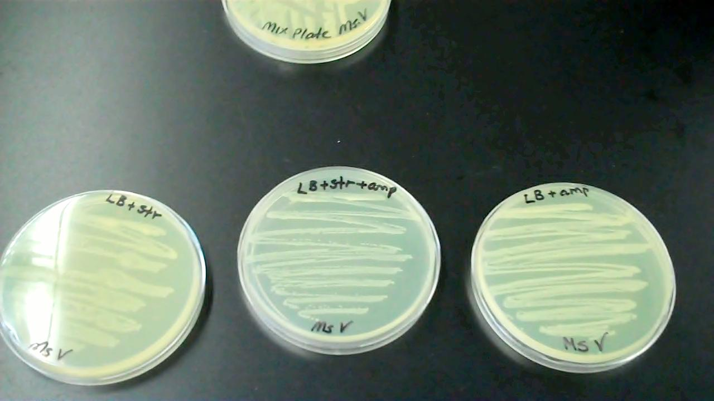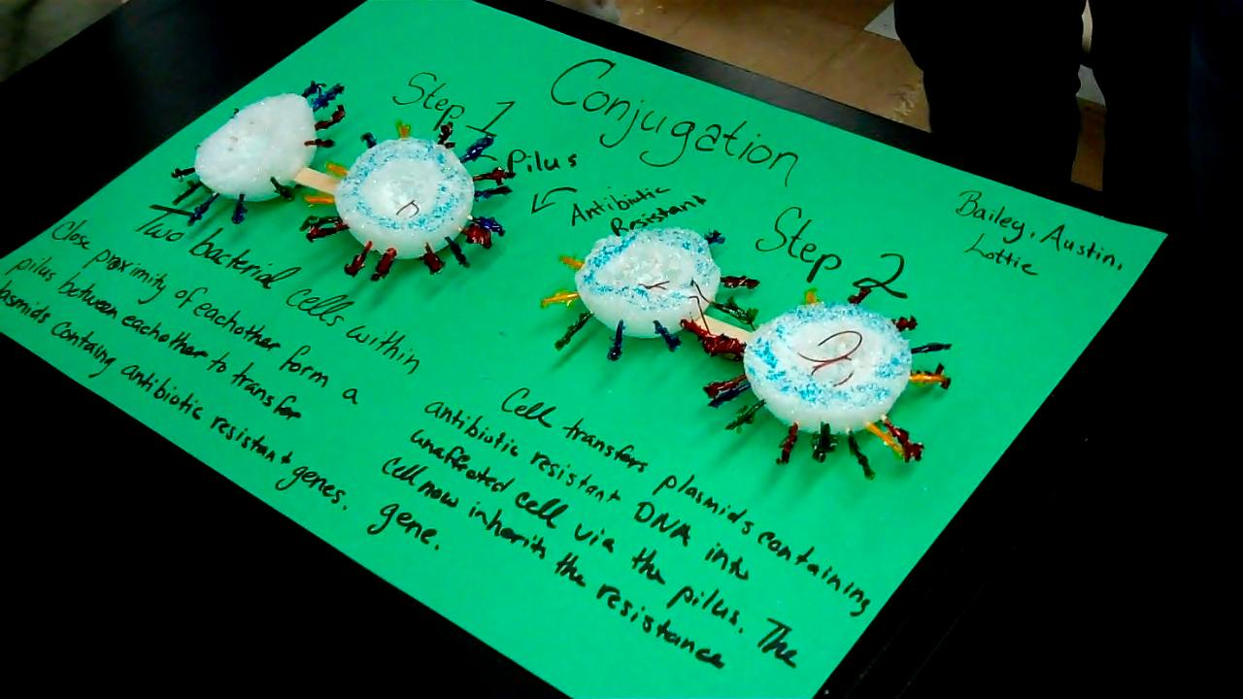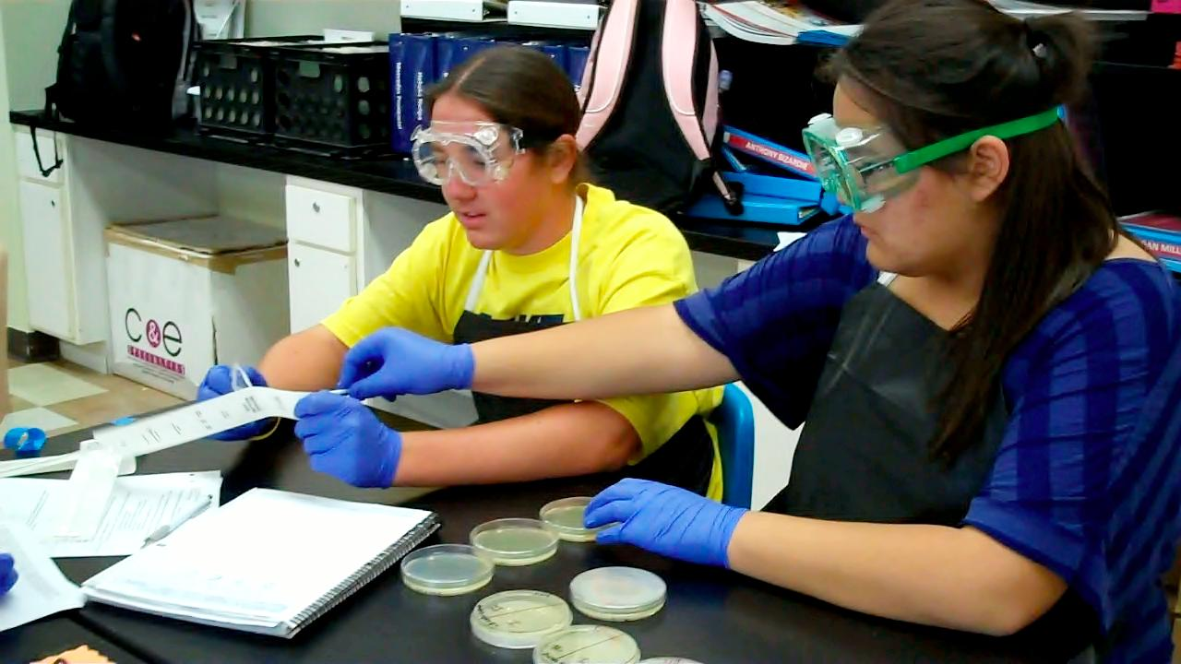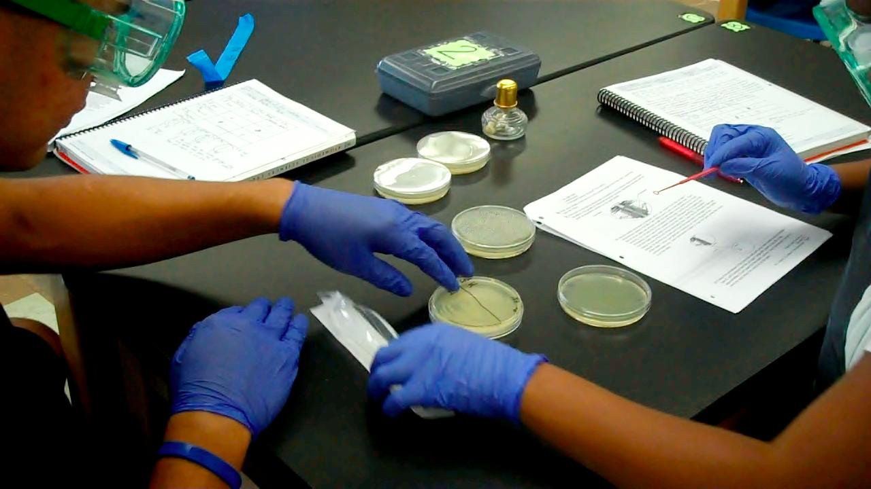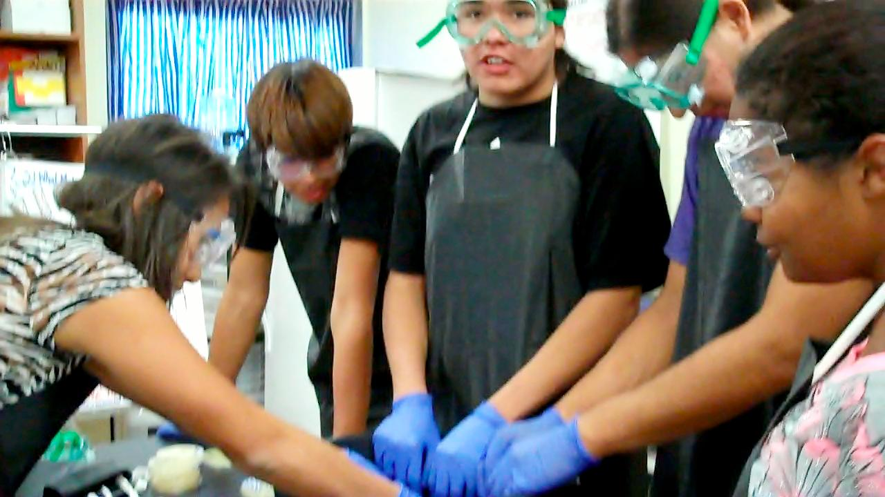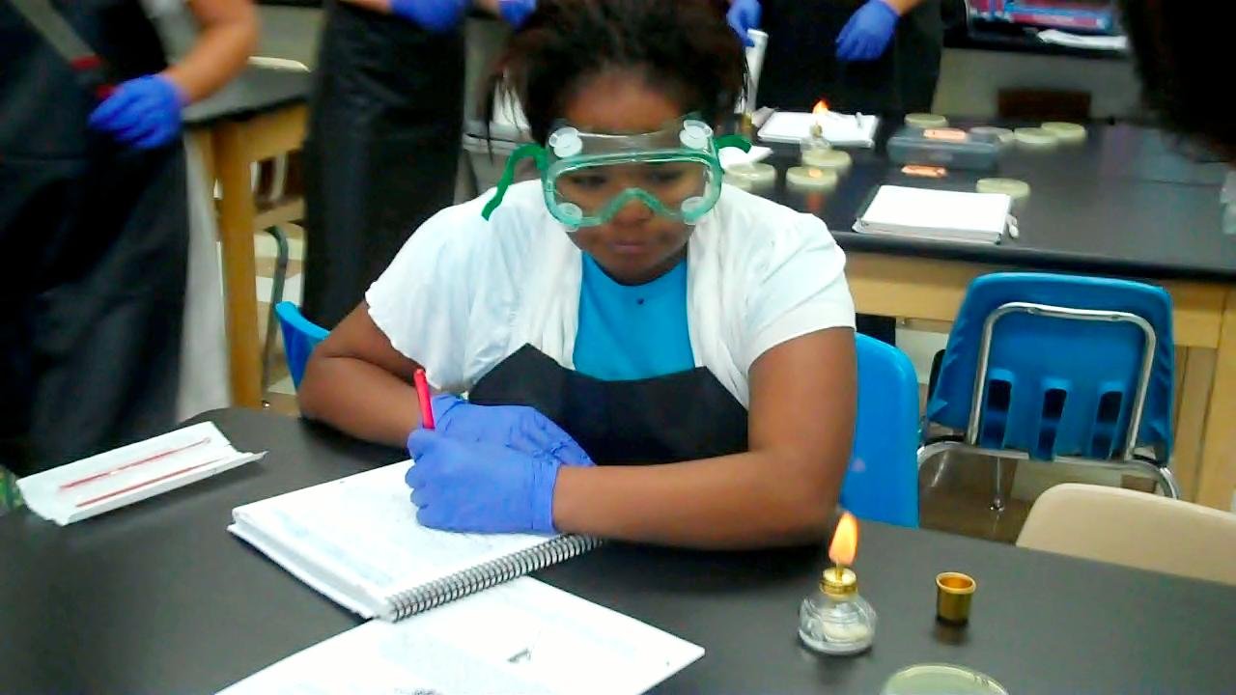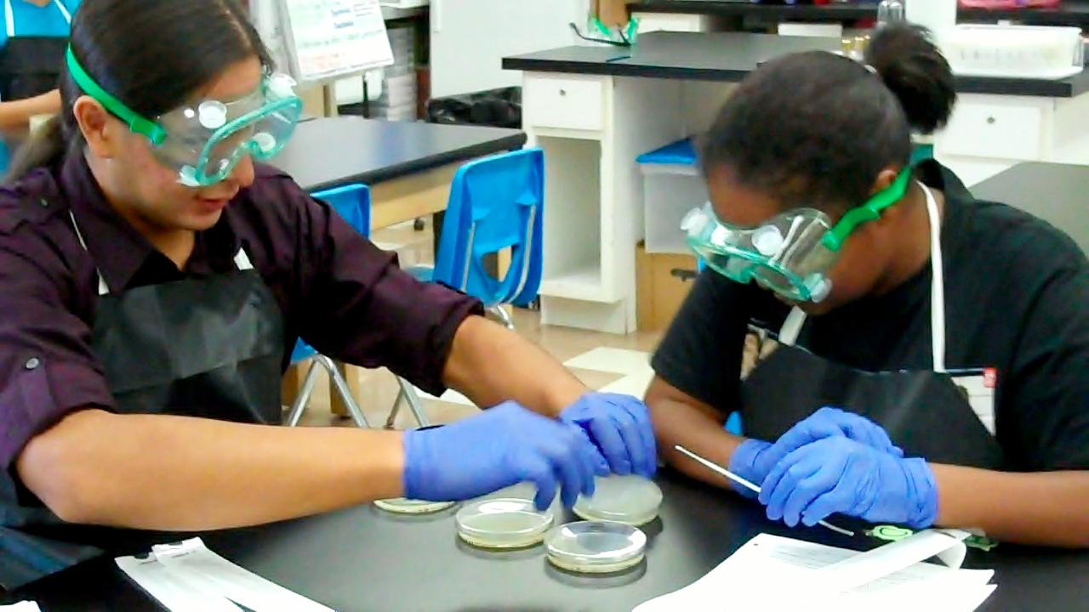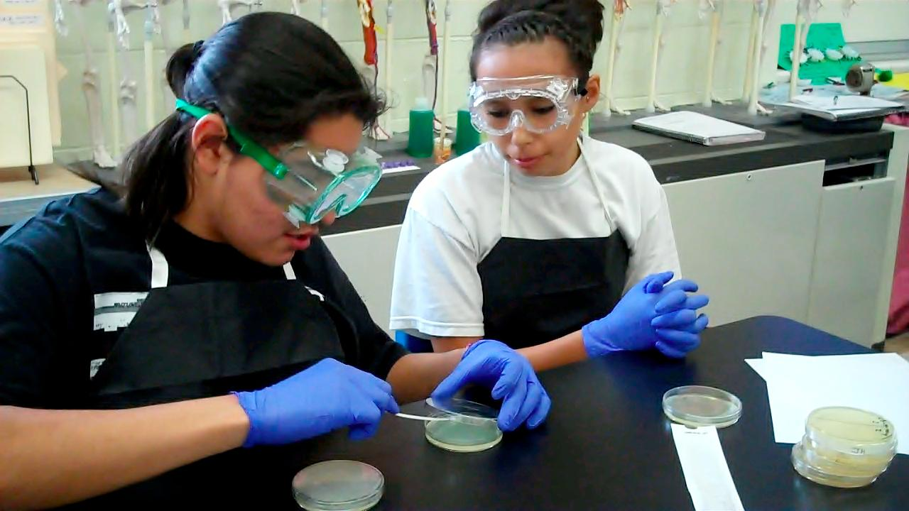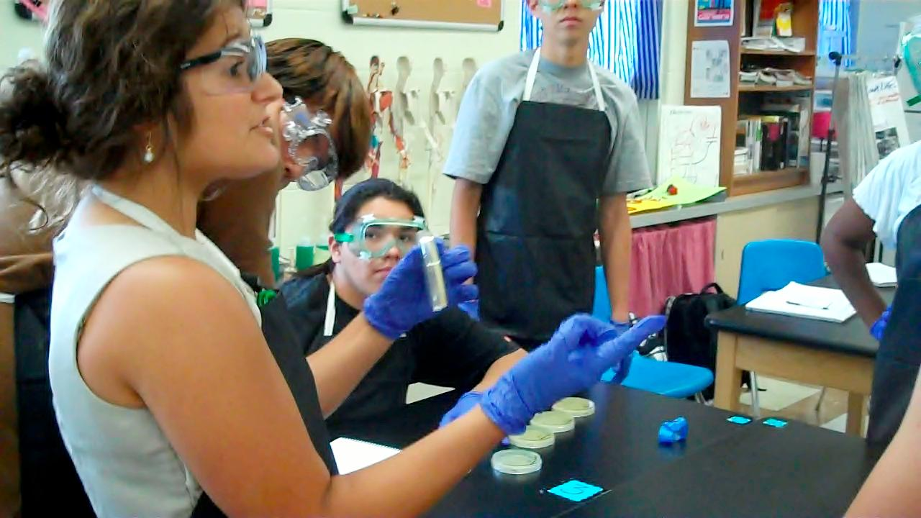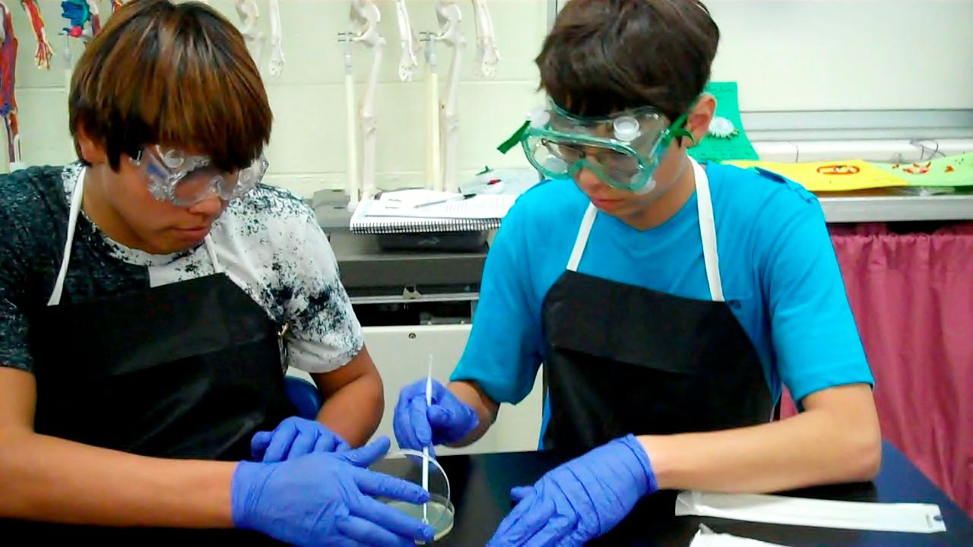

Over the last decade, almost every type of bacteria known to cause disease has become stronger and less responsive to antibiotic treatment. Antibiotic resistant bacteria are threatening communities with strains of infectious diseases. Tuberculosis, gonorrhea, malaria, skin infections, pneumonia, and ear infections are just a few of the diseases that have become harder to treat. For this reason, antibiotic resistance has been called one of

the world’s most pressing public health problems and is one of the Centers for Disease Control’s top concerns.

In class, students investigated the mechanisms by which DNA from one bacterial cell is transferred to another bacterial cell. When the DNA that is transferred carries an antibiotic resistant gene, the intercellular transfer enables the new cell to become antibiotic resistant. Over time, one bacterial cell containing an antibiotic resistant gene could lead to an army of superbugs. In this special edition, you can see the skills students worked on for this lab.

# SUPERBUG

## **The Problem**

###### Class website: http://toddcountyhs.weebly.com/pltw.html

**pg.1**

SPECIAL EDITION: Family Night

Join us as we walk you through one of the labs we performed in class called Attack of the Superbug. This edition contains high level science content so please ask your students to help explain the lab, what they did, and the results they obtained. This will be a great review for them. HAVE FUN!

**MEDICAL INTERVENTIONS**

Ms. Verrochi’s Class Newsletter

Please continue to urge your students to study and prepare for Unit 1 Test for Thursday 9/20.

**Day 4 – Observe Plates to Test for Antibiotic Resistance**

Students saw that their hypothesis was correct. Both strains of bacteria now had both Streptomycin Resistance AND Ampicillin Resistance as seen because bacteria grew on all three plates: (LB+str) streptomycin antibiotic, (LB+amp) ampicillin antibiotic, & (LB+str+amp) streptomycin and ampicillin antibiotics.

We plated bacteria that we mixed together on the plates containing antibiotic to see if the bacteria conjugated, and shared their DNA with the antibiotic resistance.

**Day 3 – Streak Cultures from Mix Plate to Antibiotic Plates**

**Day 2 – Observe Confirmation Plates; Prepare Mix Plate**

We confirmed that Strain I was Streptomycin Resistant and Strain II was Ampicillin Resistant. Now we put the two bacteria strains together to see if they would conjugate, or share their plasmid DNA.

Strain I E.coli was streptomycin resistant and strain II E.coli was ampicillin resistance. We wanted to confirm resistance, so we plated both bacteria on plates the contained (1-LB) no antibiotic, (2-LB+str) streptomycin antibiotic, (3-LB+amp) ampicillin antibiotic, (4-LB+str+amp) streptomycin and ampicillin antibiotics.

**cont.**

**Day 1 – Prepare Confirmation Plates**

#### Ever wonder what happens when you don’t take all your antibiotic?