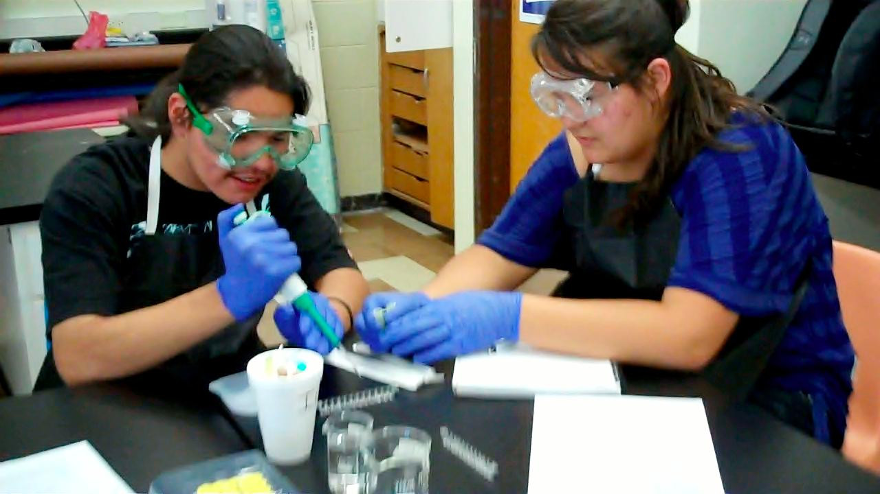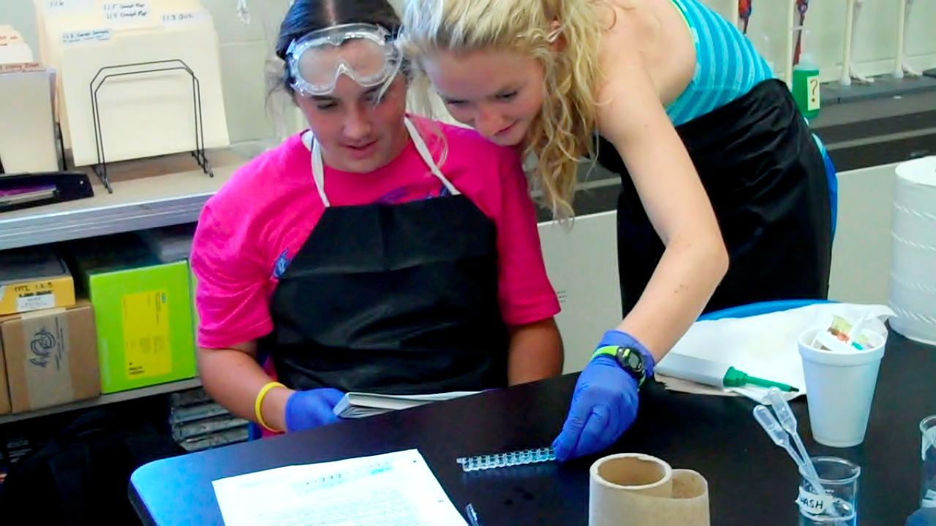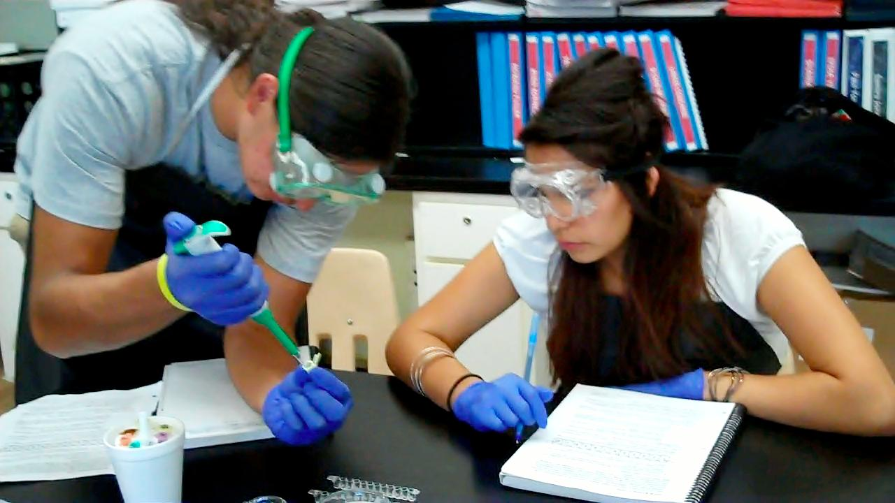**[](http://1.bp.blogspot.com/_IwrVxMXC70o/TGQDzOXeGzI/AAAAAAAAA2U/6TAzEaf3ywQ/s1600/PLTW.jpg)**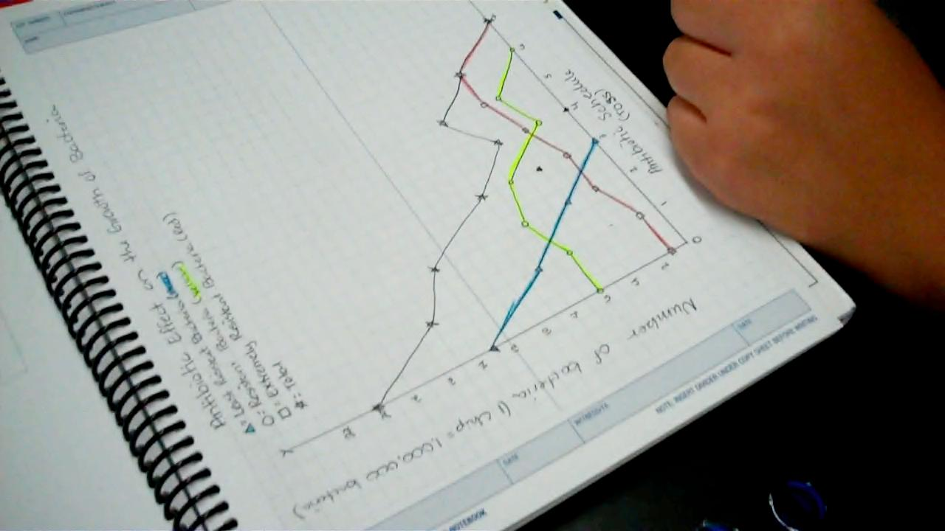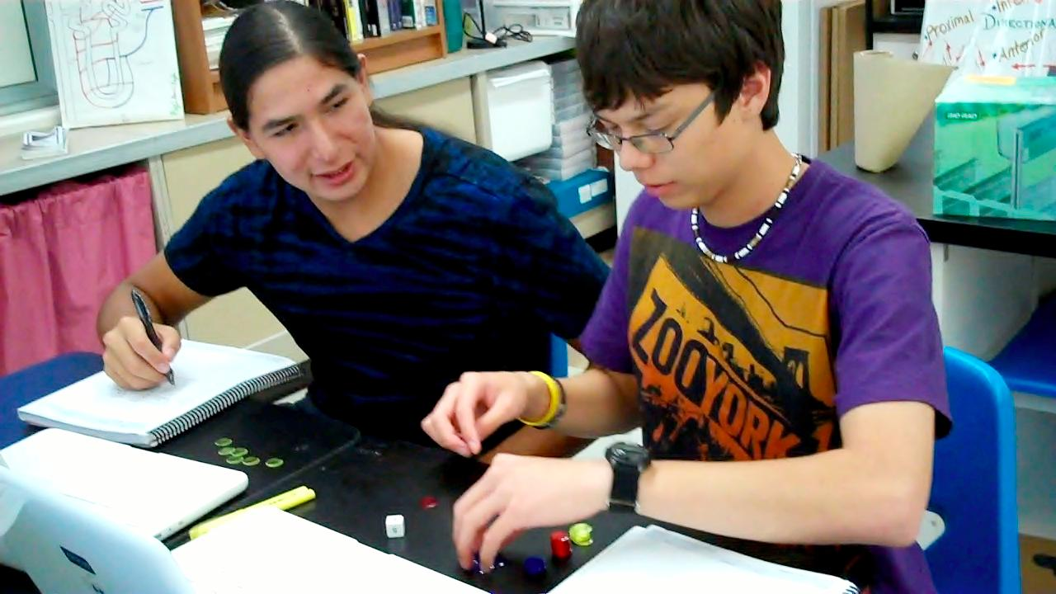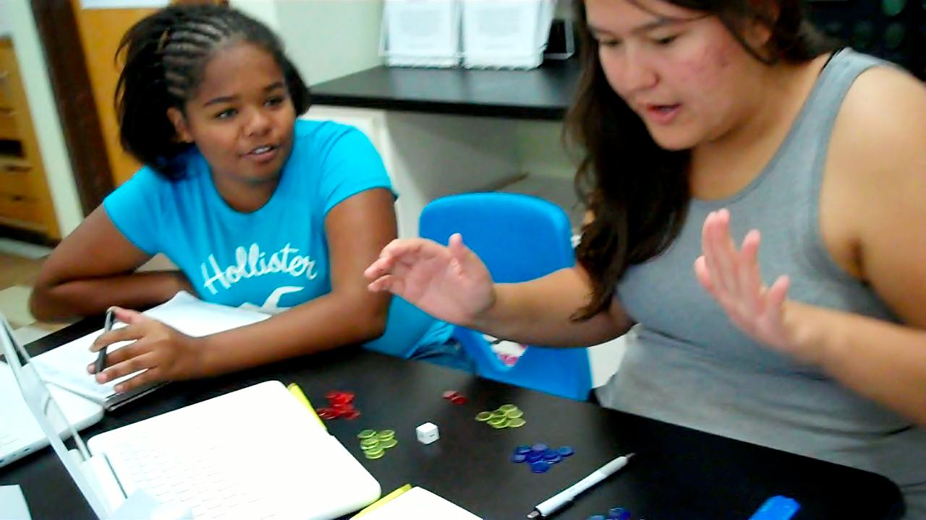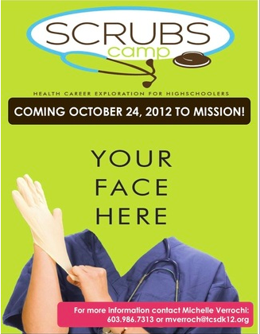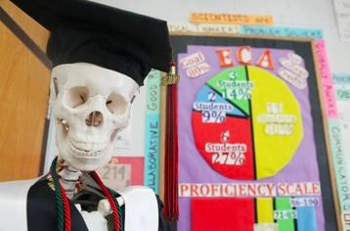

The pictures feature students performing an ELISA test to determine which patients have bacterial meningitis

###### Class website: http://toddcountyhs.weebly.com/pltw.html

**pg.1**

**SPECIAL EDITION – SUPERBUG coming this family night**

In the first unit, students are introduced to Sue Smith, the eighteen-year-old daughter of Mr. and Mrs. Smith. Sue is a college freshman who is presenting symptoms of an unknown infectious disease, which students eventually identify as bacterial meningitis. Sue survives the infection but is left with hearing impairment. Through this case, students will explore the diagnostic process used to identify an unknown infection, the use of antibiotics as a treatment, how bacteria develop antibiotic resistance, how hearing impairment is assessed and treated, and how vaccinations are developed and used to prevent infection. Continue to probe students throughout the year on what they are learning about and have them explain concepts to you as a good practice.

Feel free to contact me:

E-mail: mverroch@tcsdk12.org

Phone: (603) 986-7313

Please join me for **Family Night**

Wednesday September 19th

and see what your students are working on in class.

## **Sue Smith – Outbreak at College**

Volume 1 Sept 2012

Welcome to the third course of Project Lead The Way. The Medical Intervention course investigates the variety of interventions involved in the prevention, diagnosis, and treatment of disease as they follow the lives of a fictitious family, the Smith’s.

# Setting The Stage

To contact

Ms. Verrochi

**MEDICAL INTERVENTIONS**

Ms. Verrochi’s Class Newsletter

Before the discovery of antibiotics, countless children died of common bacterial infections. A scratch on a finger could lead to a deadly infection. But with the mass use of antibiotics, new strains of bacteria that are resistant to antibiotics have emerged.

If you have been prescribed an antibiotic lately, your doctor probably told you to finish the entire prescription even if all your symptoms clear up before you are finished. Have you ever wondered why this was necessary? The misuse of antibiotics is one of the main causes of antibiotic resistance.

In this activity students used models to determine the effect of the antibiotic on the pneumonia using colored disks to represent the bacterial infection.

Upcoming events this Fall:

**Family Night**  September 19th @ TCHS

Families visit with staff 4:00-6:45; tailgate supper served, Coronation begins at 7:00pm

**SCRUBS** **Camp** October 24th @ SGU

Free, one-day, hands-on health career camps for high school students. Students will have the opportunity to experience a wide variety of health careers through hands-on activities and discussions.  After the SCRUBS Camp, attendees will be eligible to apply for a field experience where they can shadow a health care professional of their choice.  This is the first year Mission will host a camp!

**Parent/Teacher Conferences** November 1st and 2nd

Thursday 1st – 12pm – 4pm

Friday 2nd – 8am – 12pm

**ECA Tentative Testing Date** December 6th and 7th

**Job Shadow/Intern at Local Healthcare Settings**

**HIPAA Training** TBD @ Rosebud Hospital

Starting in 2012-2013, students will be able to complete a number of job shadow hours in the community.  This will give students valuable exposure to a variety of heath care professions and give them an idea of what responsibilities the job entails and analyze if the job is a good fit for them.  They will use these hours to complete a capstone project for the fourth PLTW course: BI.

**SENIORS should begin applying to *colleges*! See me about recommendations and further scholarship opportunities.**

**EARN COLLEGE CREDIT!**

NEW! This year our PLTW program is working towards certification. Once we are certified, students can earn college credit for taking all four PLTW courses and earning a 3.00 or higher in them. Please encourage your students to take the fourth course in the spring called Biomedical Innovations – the capstone, project-based class.

Just as with the previous two courses, students enrolled in this course will have the opportunity to earn biology college credit if they earn an 80% or better on the End-of-Course Assessment (ECA). The assessment will be administered in December.

**cont.**

#### Ever wonder what happens when you don’t take all your antibiotic?

This week students have been measuring vital signs of the heart

Justo id eleifend faucibus, urna dolor consectetuer dui, vel pretium risus purus sed pede. Integer diam elit, facilisis eget.

Donec varius, felis eget lobortis vehicula, magna sapien elementum tellus, ut iaculis dui orci sed arcu. Nullam semper leo.