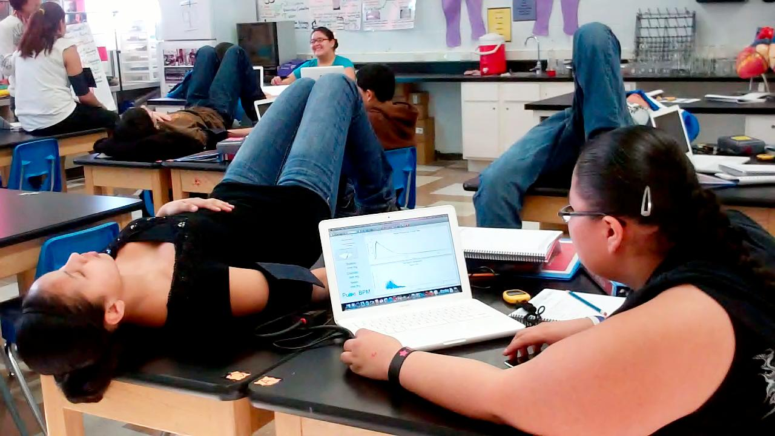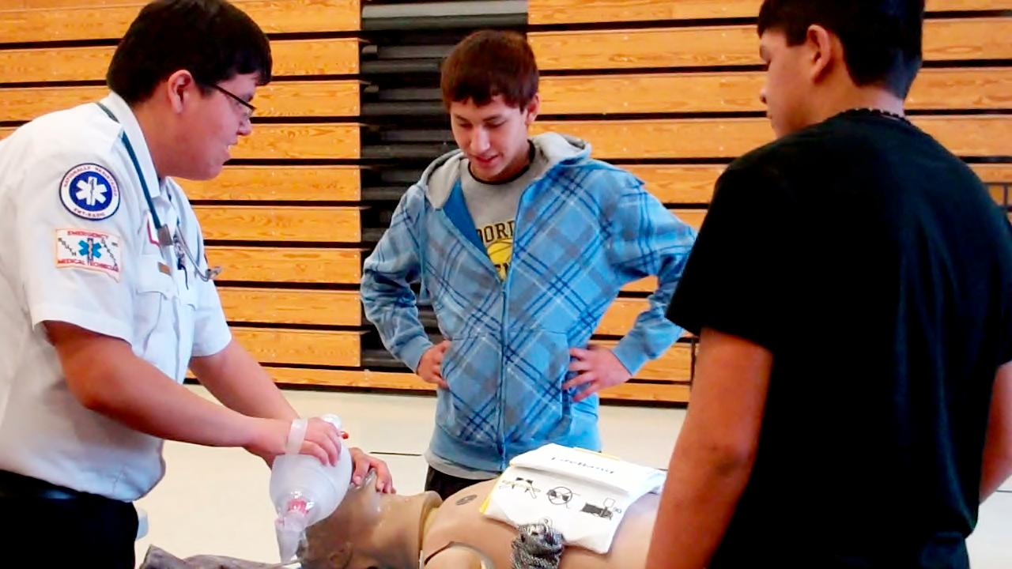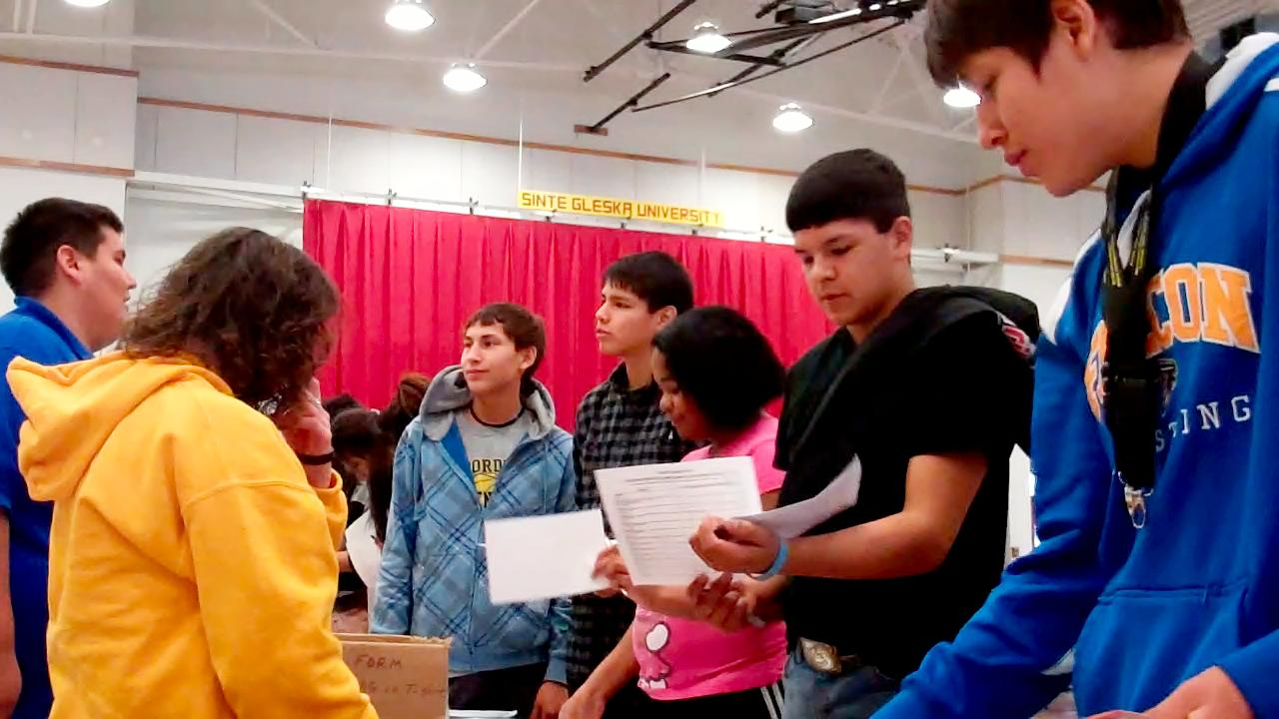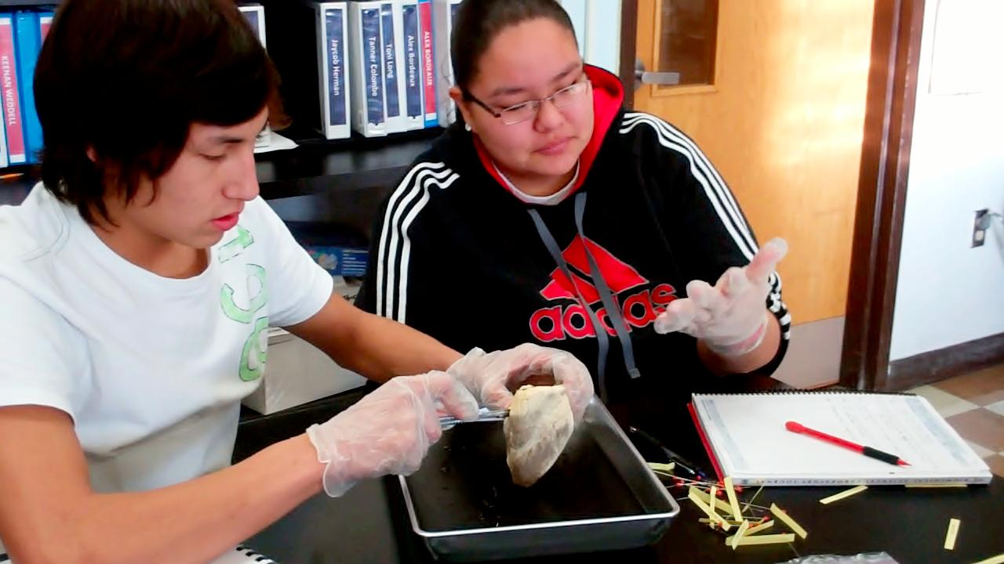**[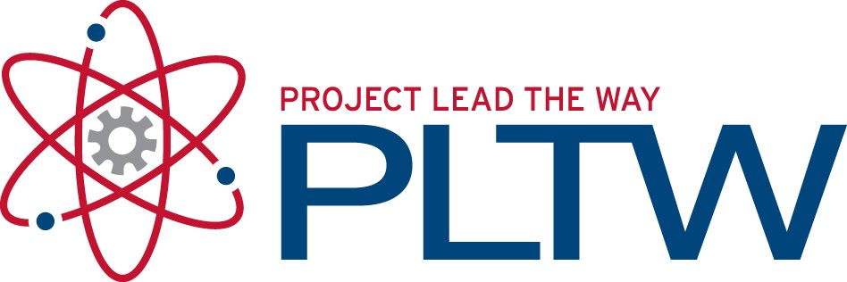](http://1.bp.blogspot.com/_IwrVxMXC70o/TGQDzOXeGzI/AAAAAAAAA2U/6TAzEaf3ywQ/s1600/PLTW.jpg)**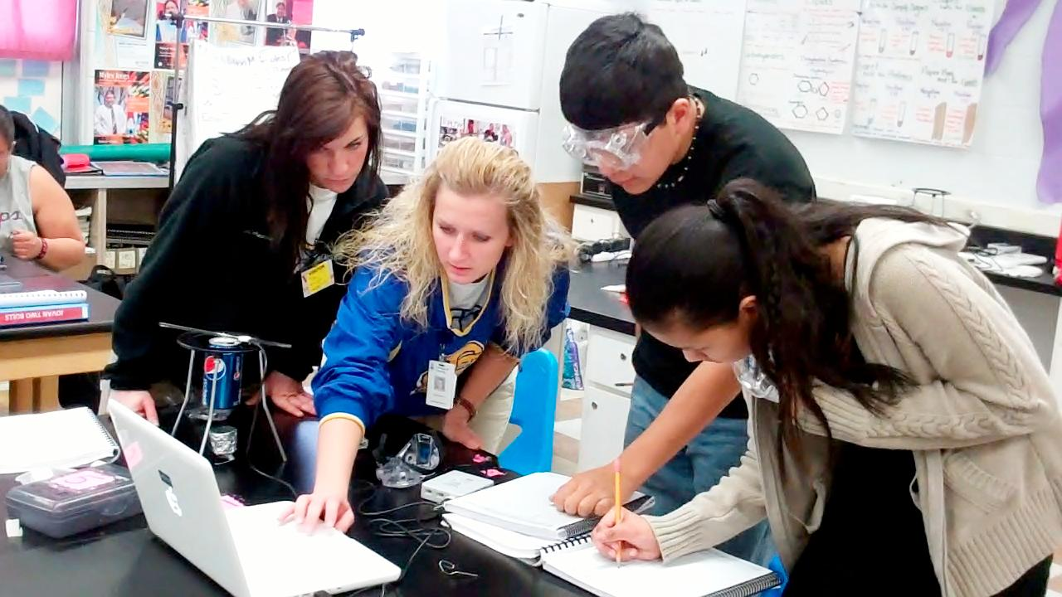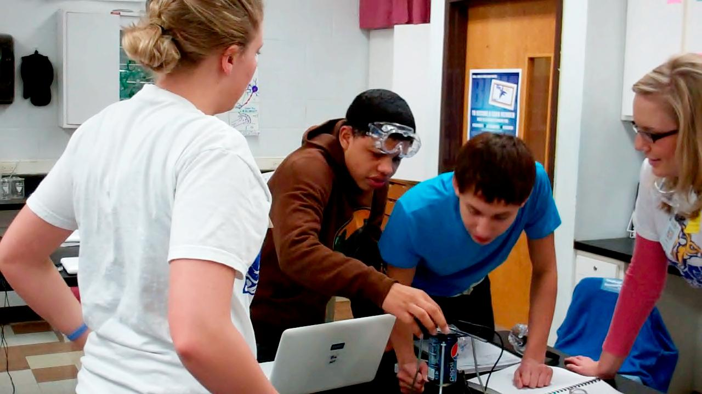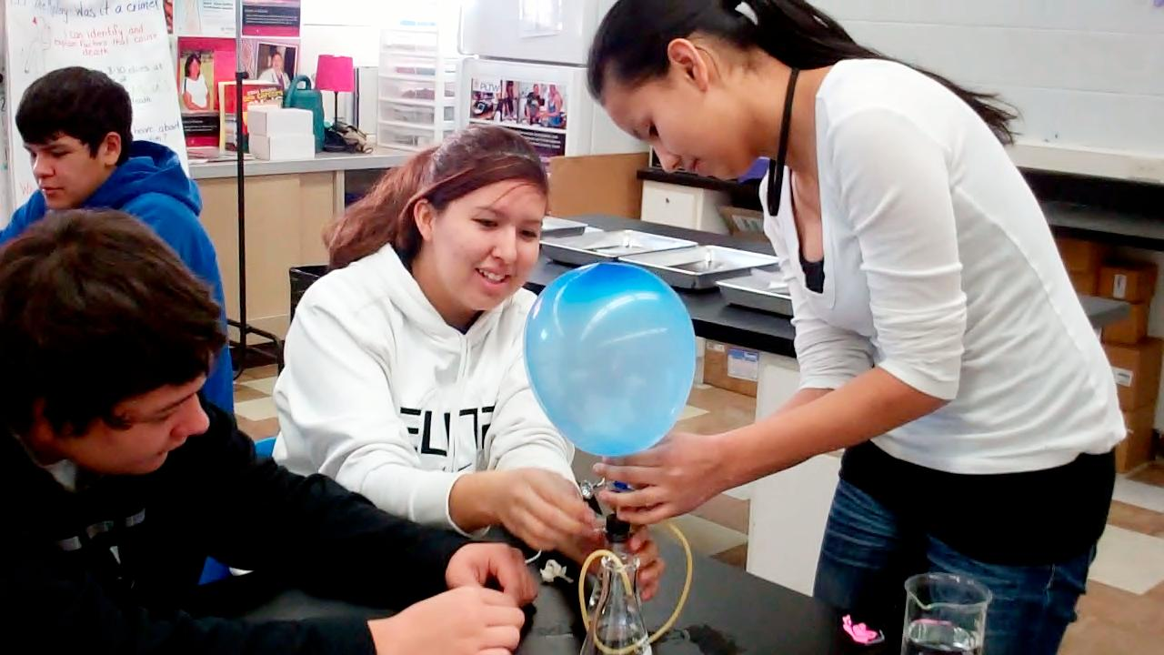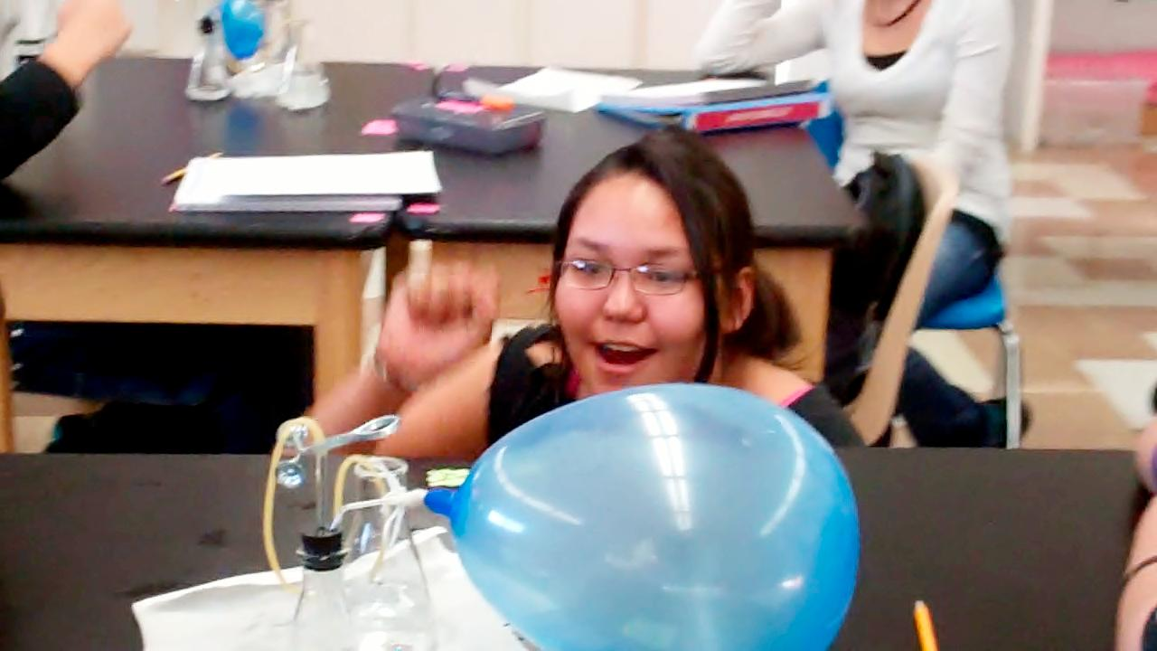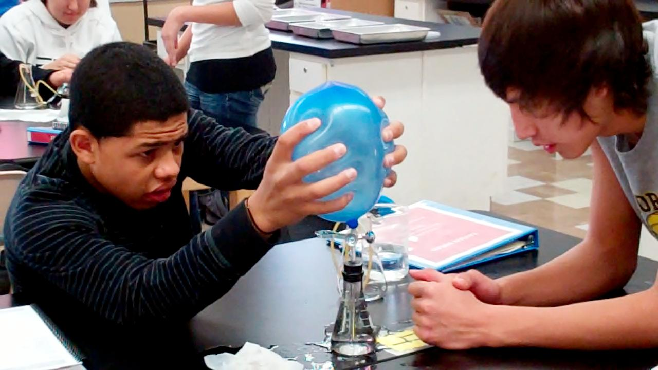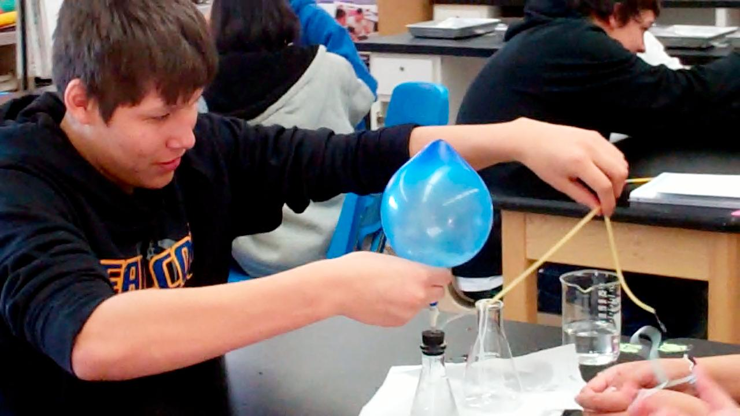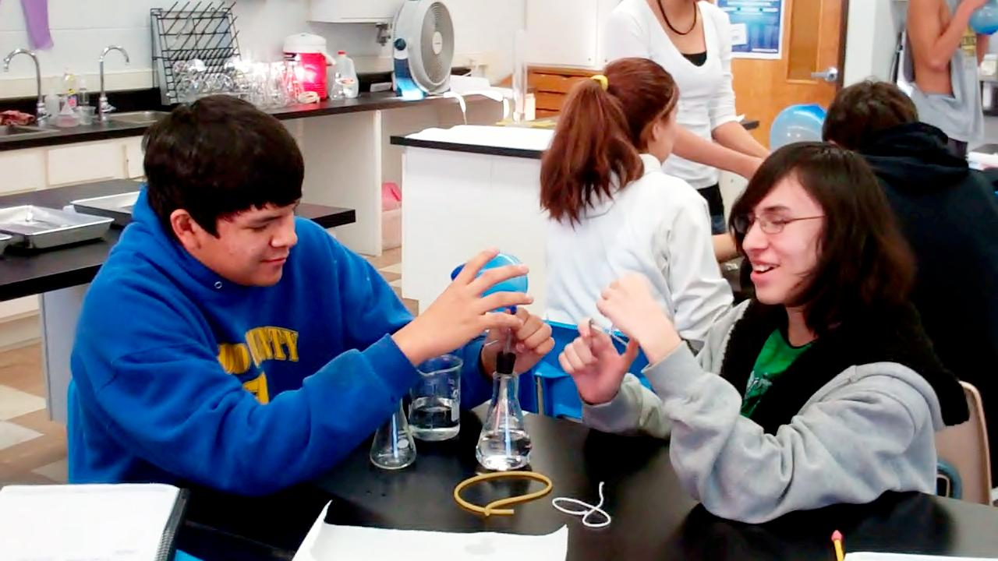

Feel free to contact me:

E-mail: mverroch@tcsdk12.org

Phone: (603) 986-7313

Website: <http://toddcountyhs.weebly.com/pltw.html>

*(recently updated)

To contact

Ms. Verrochi

Students attended the 2nd Annual Healthcare Careers Day at SGU. They got to learn about healthcare careers in the Rosebud community and summer and college opportunities. The pictures show students interacting with professionals including Beaux Beauvais, a ‘10 TCHS graduate who is currently enrolled in Creighton to become a paramedic. The students represented Todd County High School and PLTW proud and walked away with some cool door prizes!

## **Sinte Gleska University**

## **Multipurpose Building**

## **March 7th, 10am-2pm**

# 2nd Annual Healthcare Careers Day

Students designed experiments to see how exercise, body position, and external stimuli affect heart vital signs. Above, students use Vernier sensors and computer software to record vital signs including blood pressure, heart rate, and EKGs. Students are also dissecting sheep hearts.

Principles of Biomedical Sciences

###### Look for more publications!

**pg.1**

Volume 2 February/March 2012

Ms. Verrochi’s Class Newsletter

In unit 2 students have been practicing many lab skills necessary for health related fields. Students preformed dissections on pig hearts to apply their knowledge of the heart anatomy and forensic pathology. Students also learned how to measure and read heart vital signs and use problem solving skills to create pumps out of only the materials provided. In addition, students have been working with the microscopes to examine different tissues in the body and to learn about blood composition. The Biomedical Sciences program offers advantages to students including career readiness and hands-on experience. This college preparatory class is full with labs and creative exercises to prepares students to succeed in the classroom and in college. SDSU nursing students visited in February to help students complete a calorimetry lab.

**John and Mark**

Build A Pump – Learning Problem Solving Skills

**cont.**

**Tanner**

**Seth, Kelsey, and Jailyn**

**Tavian and Gabe**

**LaShay**

This week students have been measuring vital signs of the heart

#### Students learn essential laboratory skills.

Donec varius, felis eget lobortis vehicula, magna sapien elementum tellus, ut iaculis dui orci sed arcu. Nullam semper leo.