**[](http://1.bp.blogspot.com/_IwrVxMXC70o/TGQDzOXeGzI/AAAAAAAAA2U/6TAzEaf3ywQ/s1600/PLTW.jpg)**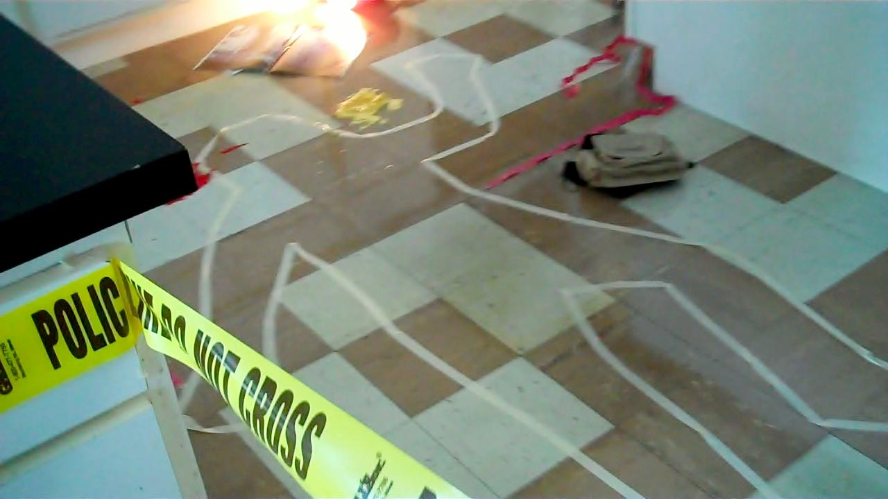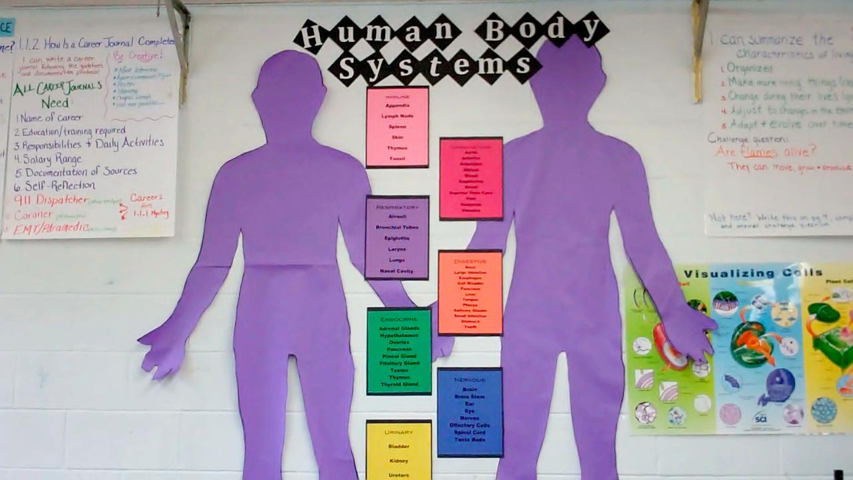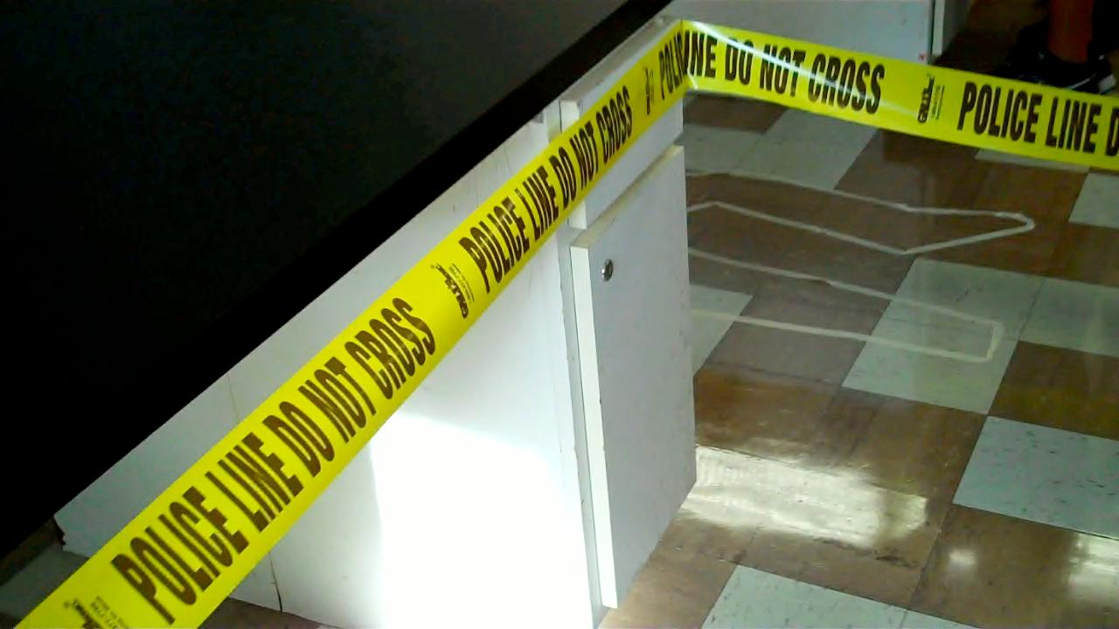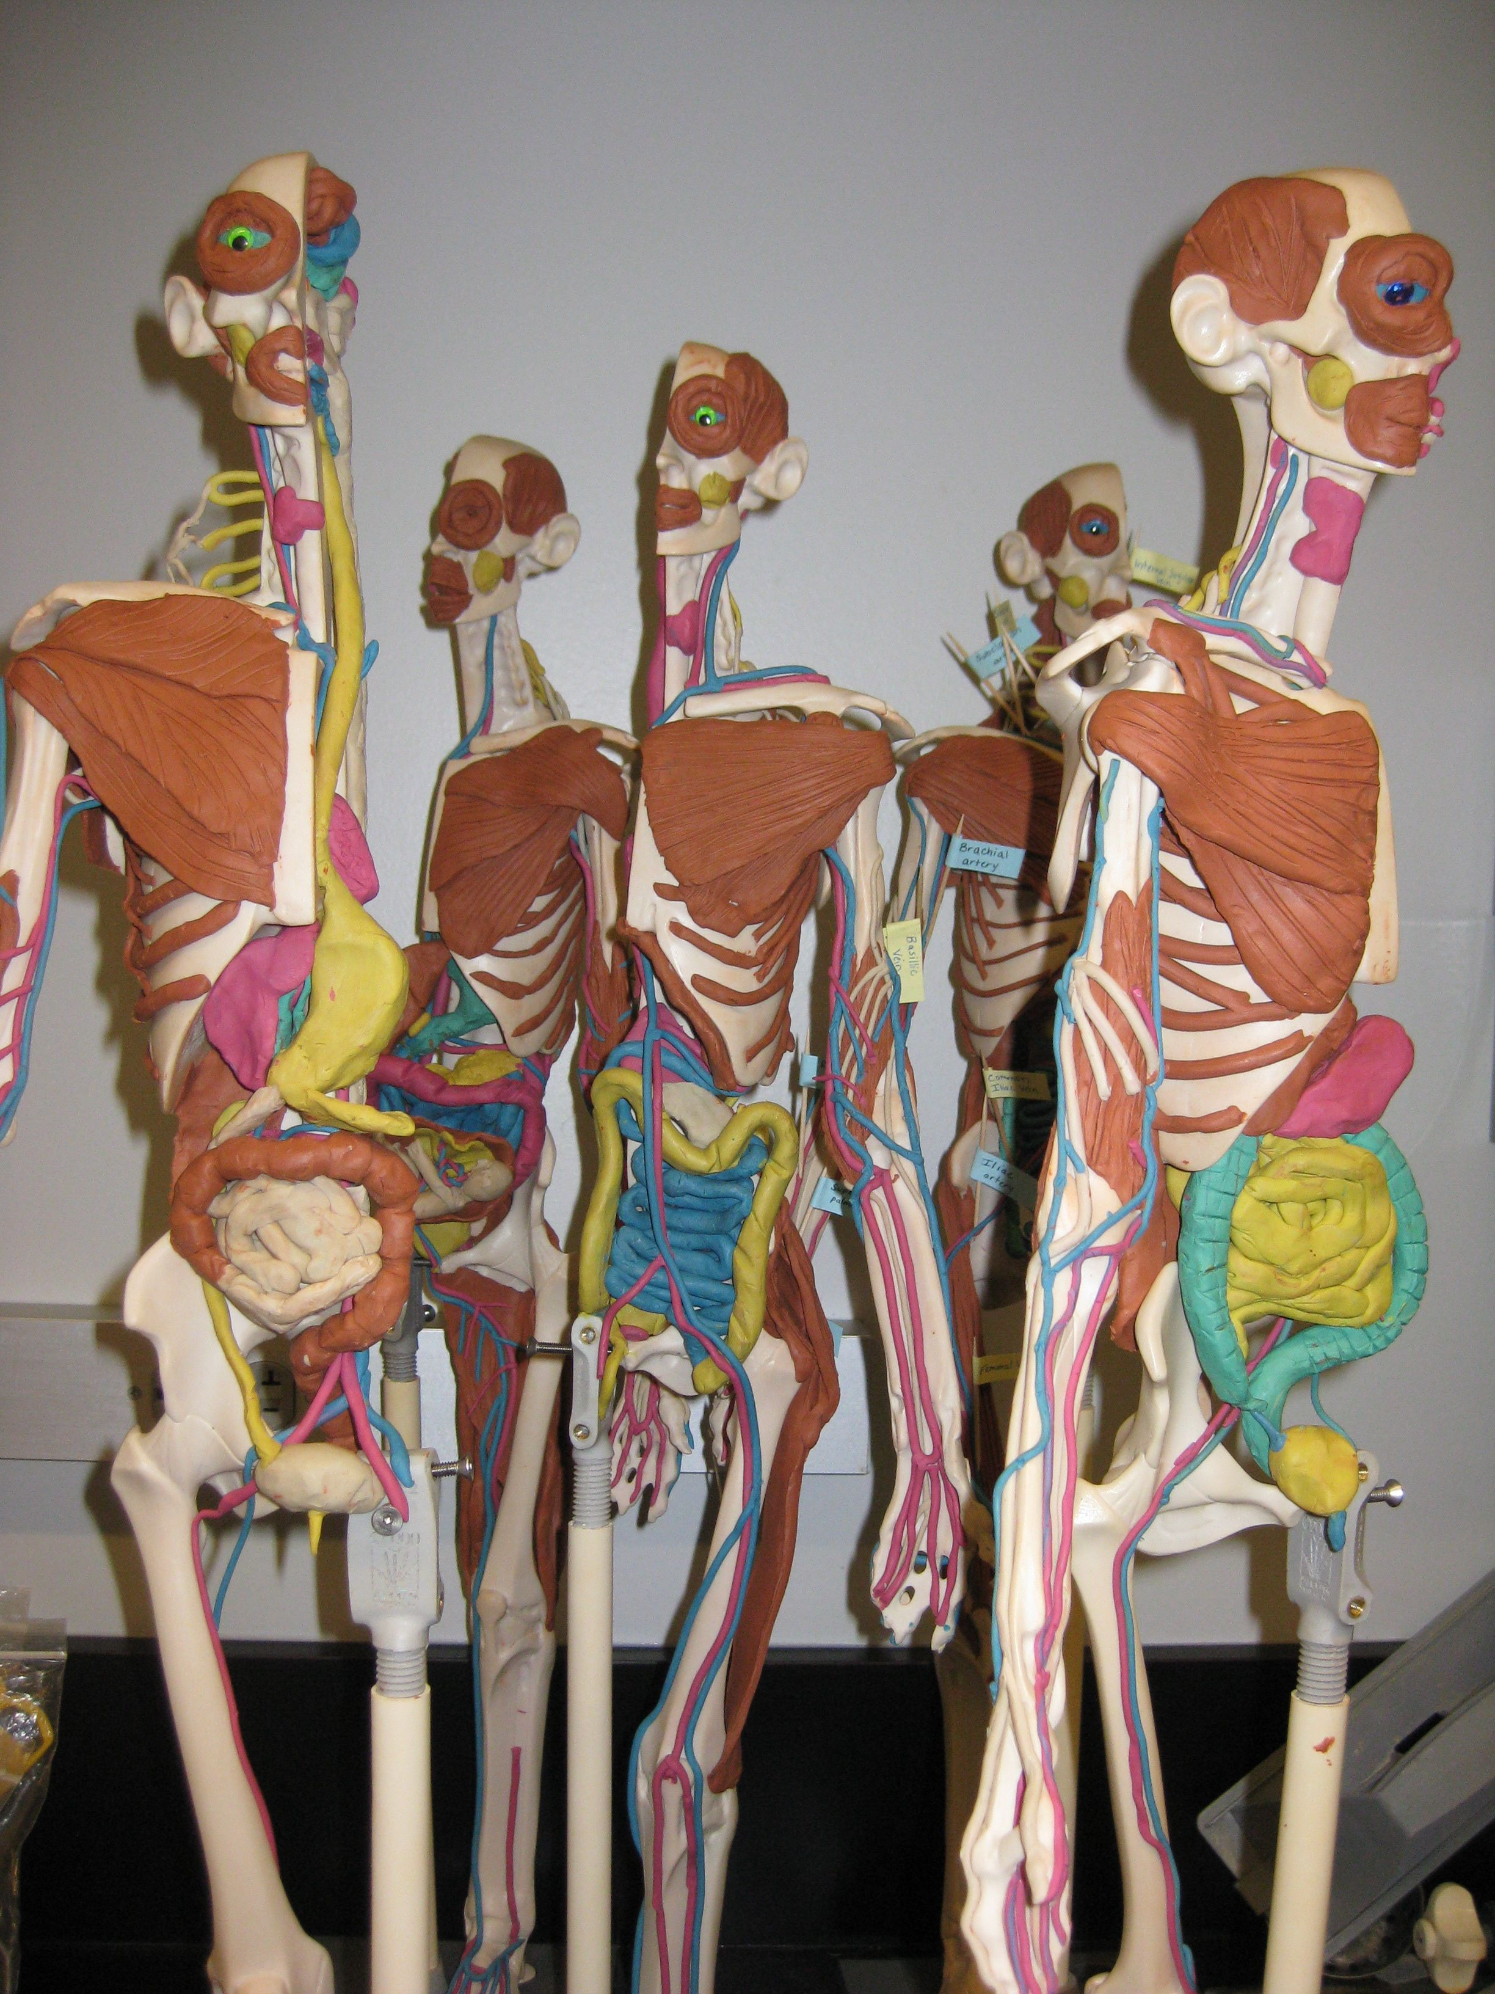

This week students have been learning about what causes death by exploring a fictitious crime scene. We have also been exploring related biomedical careers including 911 Dispatcher, Coroner, and Paramedic. Watch the class movie to find out what the class is about at our website: http://toddcountyhs.weebly.com/pltw.html

Please feel free to contact me if you have questions or concerns. Also please reach out to me if would like to visit or be a guest speaker in the classroom.

E-mail: mverroch@tcsdk12.org

Phone: (603) 986-7313

Website:

http://toddcountyhs.weebly.com/pltw.html

To contact

Ms. Verrochi

**Fictitious crime scene on Day 1 of class**

## **Project Lead the Way is a national, educational program that assists high-school students in developing strong backgrounds in science.**

# Project Lead The Way at Todd County High School

Principles of Biomedical Sciences

Principles of Biomedical Sciences provides an introduction to the biomedical sciences through exciting hands-on projects and problems. The theme throughout the course is to determine the factors that led to the death of a fictional person. After determining the factors responsible for the death, the students investigate lifestyle choices and medical treatments that might have prolonged the person’s life. This class will be rigorous, challenging, fascinating, and fun. I expect that this class will motivate your child to work hard, help them learn to work well with others, and improve their higher-level thinking skills to be college and career ready.

###### Look for more publications!

**pg.1**

Volume 1 January 2012

Ms. Verrochi’s Class Newsletter

It’s going to be a great semester!

Kathy VanKley visited the class on January 27, 2012 and spoke s about summer opportunities. I encourage all students to apply for one summer experience:

* INMED – Indians Into Medicine June 11-July 20th, 2012 @ University of North Dakota Application available at *www.med.und.edu/.../updated-****2012summer****-insitute-editable.pdf* (deadline is March 31st)
* Health Careers Camp – June 17-22, 2012 @ University of South Dakota. Application available at www.usd.edu/med/health-careers-camp.cfm (deadline is April 30th)

The class will be attending the Healthcare Careers Day February 29th, 2012 at Sinte Gleska University

**EVENTS/OPPORTUNITIES**

**Anna Garcia, Crime Scene**

The second course of the program, Human Body Systems, uses Manikens ® in Clay in order to learn anatomy and physiology of the human body. In this course will work through interesting real world medical cases and often play the role of biomedical professionals to solve medical mysteries. Students will build manikins of the human body as investigate the structures and functions of body systems VERY cool stuff! This course will be available next year for students who want to continue on in the PLTW program (college credit can be earned here too).

*Students must successfully pass PBS to enroll.

C

**Exploring body systems**

Students are able to earn college credit if they score an 80% on the End of Course Assessment administered online by the program in January. We will be doing a lot of college level work and this will be a very demanding class. Students will be reading a novel over the first quarter and working on a capstone project the second quarter.

This unit began with a crime scene mystery. The victim, Anna Garcia, was found dead on the first day of school. Students work to determine the cause of death. The course is integrated with careers so students began learning about a wide variety of biomedical careers. Students will begin to explore body systems and how they work together. They will then compile an evidence board from Ms. Garcia’s death and look at autopsy.

#### Thanks for your support in making this program a success!

**cont.**

Manikens ® for HBS

Justo id eleifend faucibus, urna dolor consectetuer dui, vel pretium risus purus sed pede. Integer diam elit, facilisis eget.

Donec varius, felis eget lobortis vehicula, magna sapien elementum tellus, ut iaculis dui orci sed arcu. Nullam semper leo.