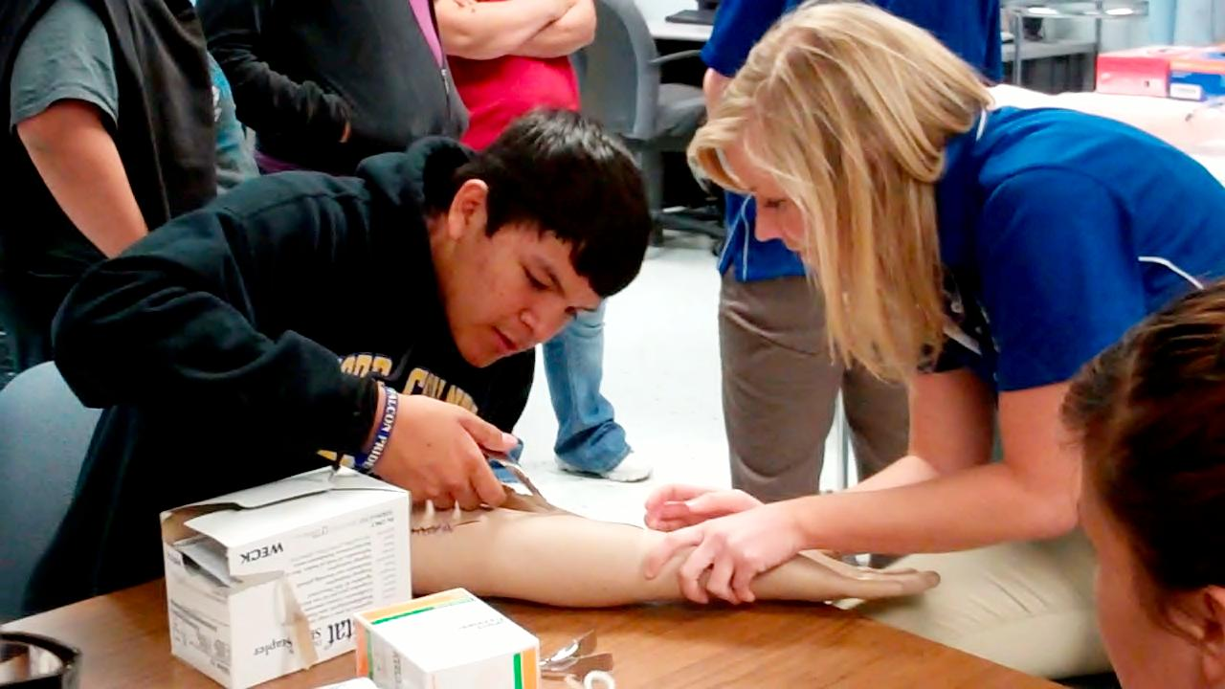**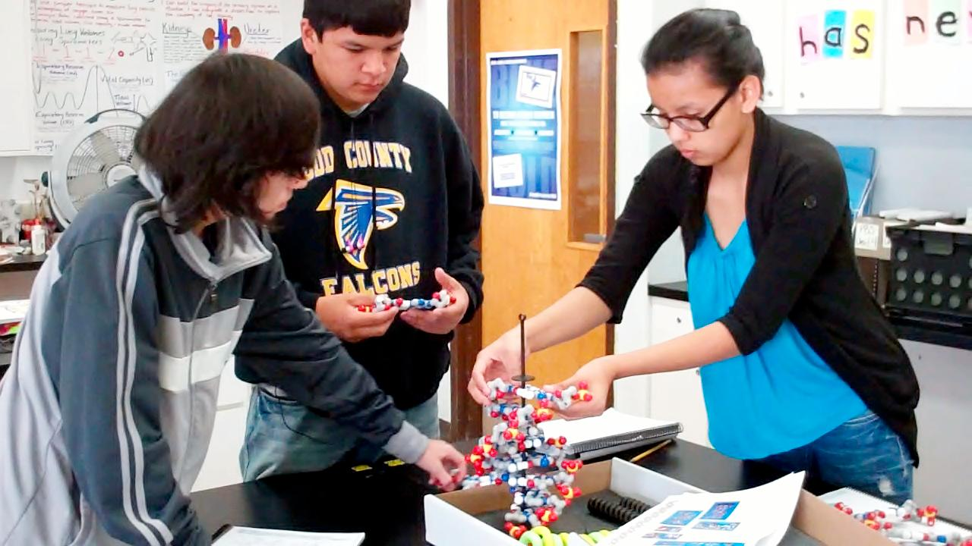[](http://1.bp.blogspot.com/_IwrVxMXC70o/TGQDzOXeGzI/AAAAAAAAA2U/6TAzEaf3ywQ/s1600/PLTW.jpg)**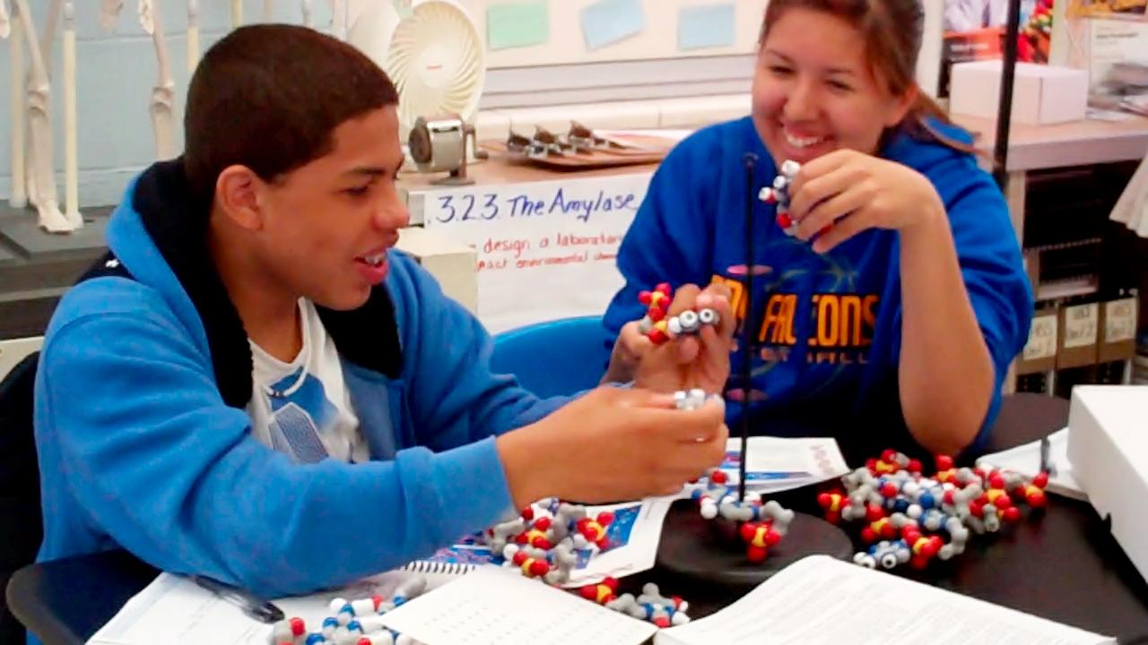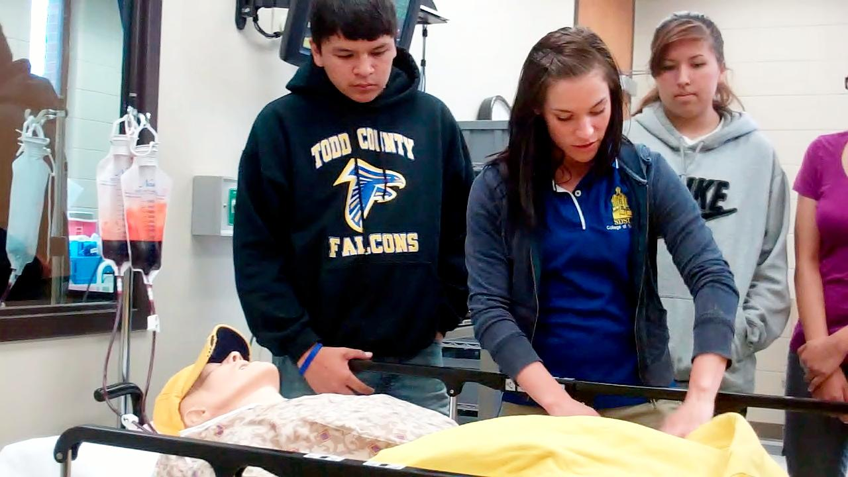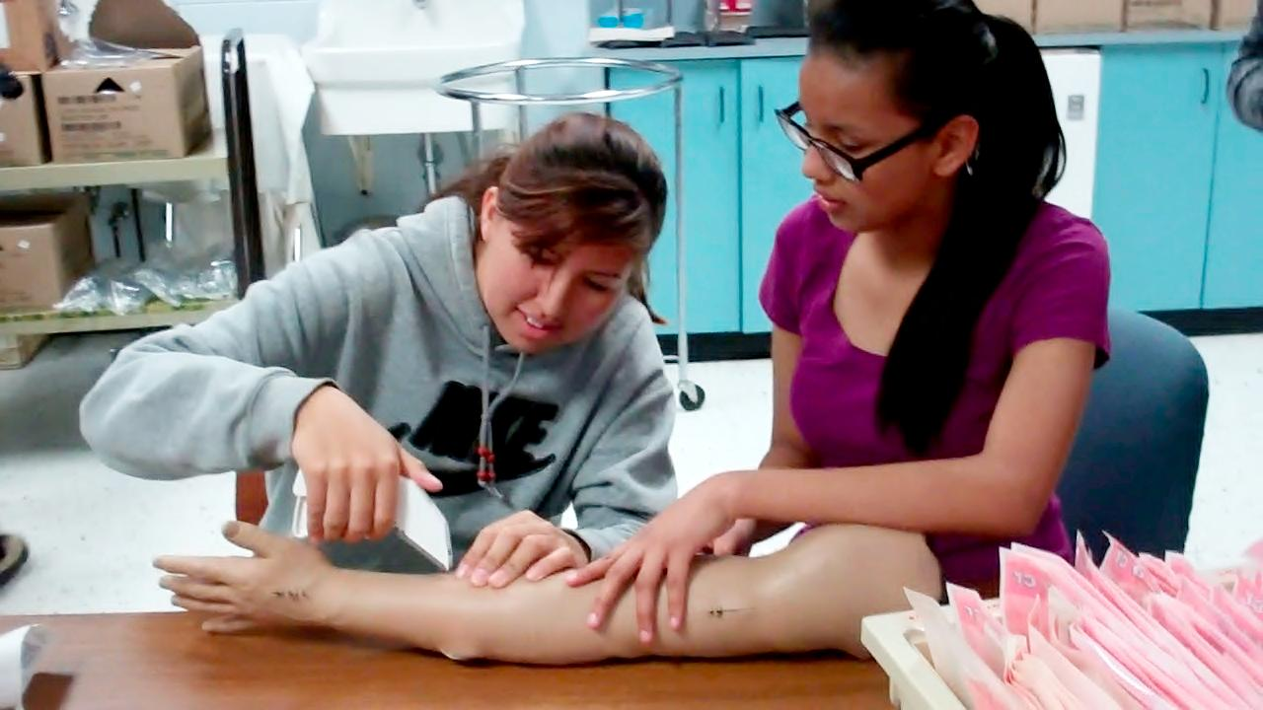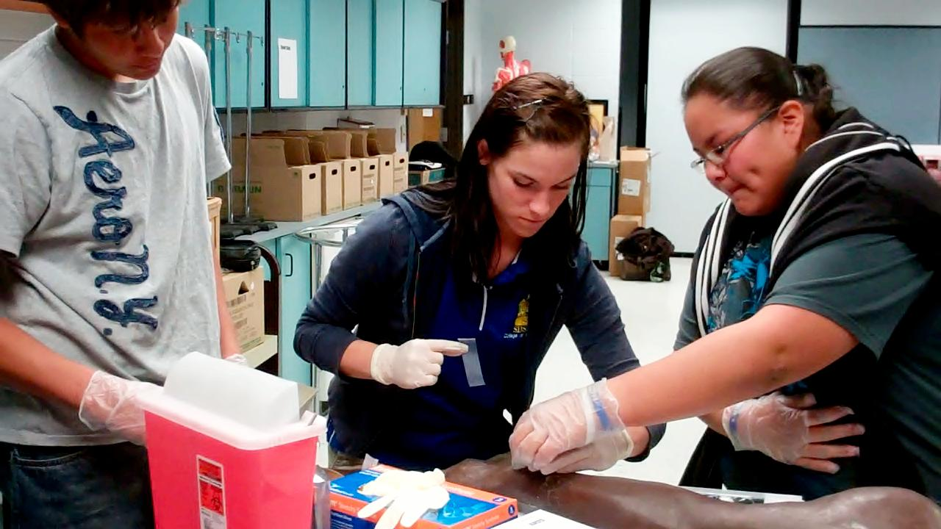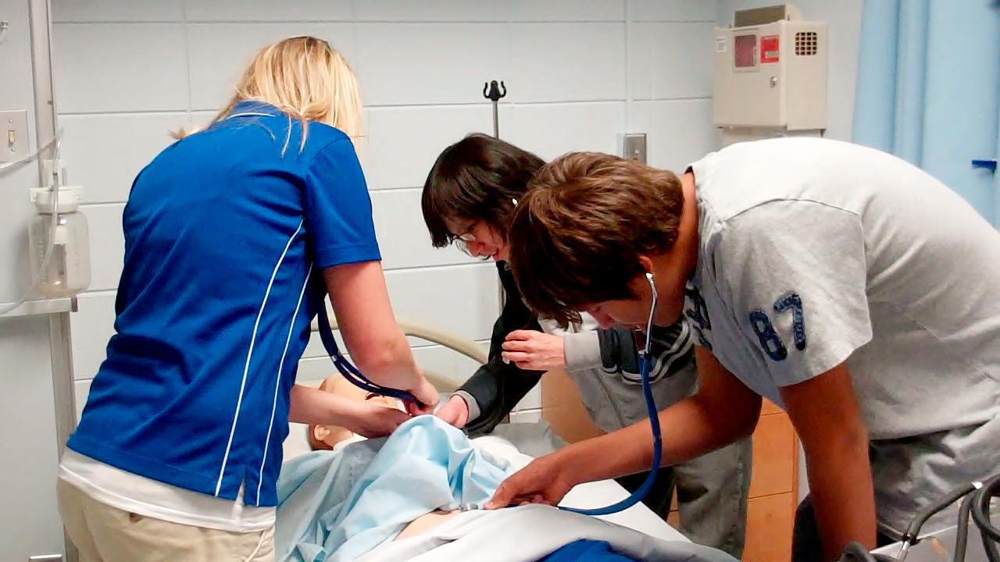

We are in the final stretch of the semester. This is the time when we start preparing for the ECA. This test is administered online by PLTW and is two parts. Part A is a 40 question multiple-choice test and Part B is an essay portion. Students have 1 hour to complete each part. If students score an 80% or higher, they will earn 3 college credits.

We have covered a lot of material in this course, so it is important to encourage your students to start reviewing NOW. I will be sending home an ECA review guide. Students should be looking over their notes/labs each night and working through the ECA. Here are some tips for testing day in early May:

1. Get a good night’s rest
2. Eat breakfast
3. Study (students can use an 8.5x11 notes page on the test)
4. Be confident

Please feel free to contact me if you have questions or concerns. E-mail: mverroch@tcsdk12.org

Phone: (603) 986-7313

Check out our class website:

http://toddcountyhs.weebly.com/

pltw.html

## **How to Prepare & Earn College Credit**

**John removing staples from an arm with SDSU nursing students on field trip last week**

# Getting Ready for the End of Course Assessment (ECA)

**Principles of Biomedical Sciences**

In Unit 4 students have been learning about Sickle Cell Disease. The focus of this unit is on genetics and how traits are inherited. Above, students learn about the structure of the DNA molecule, which carries our genetic information, by building structural models and researching about its structure.

###### Field Trip to SDSU on page 2

To contact

Ms. Verrochi

**pg.1**

Volume 3 April 2012

Ms. Verrochi’s Class Newsletter

On April 5th, seven PLTW students traveled to SDSU with SGU’s nursing students to visit the Brookings campus. in February the SDSU nursing students worked with our students on a lab and got to know each other. These SDSU nursing students arranged and hosted our students on an educational field trip to learn about their school. Below features some of the activities students got to experience on the field trip:

This state-of-the-art lab features SimMan, a computer-operated total body simulator, who can talk, breathe, simulate a human heartbeat, and act out a number of real-life scenarios, allowing students to prepare for nursing practice in a realistic environment. Students were invited into the lab to get some experience on what nursing students do to get prepare for their health career. In addition, students learned how to put on sterile gloves, put in an IV, put in and remove staples, and listen to heart and breathing sounds.

**SIMULATION LAB**

Each year the Brookings campus has 2 cadavers to work on to learn about human anatomy. Most students do not have the opportunity to work with cadavers until medical school. On the visit, students got to explore the lab and hold some of the human organs.

**cont.**

**ANATOMY LAB**

###### Mark and Tanner listening to heart sounds

###### Kelsey and Jailyn putting in staples

###### John and Kelsey diagnosing the patient

###### Jovan and Tanner putting in an IV

Students Visit SDSU

This week students have been measuring vital signs of the heart