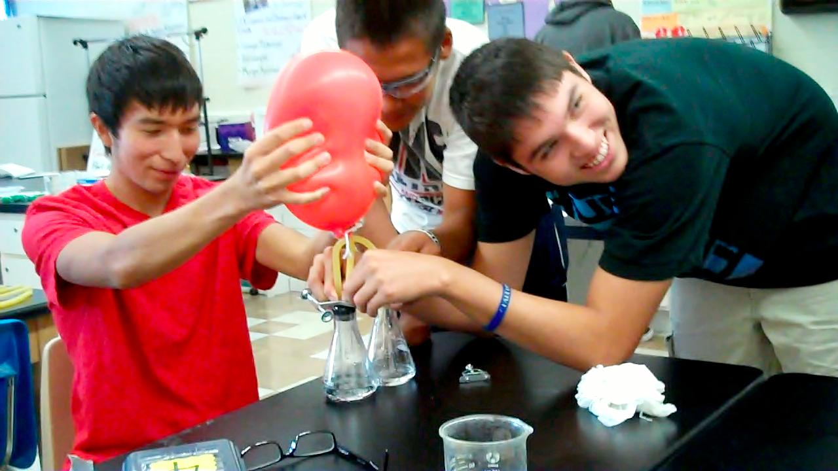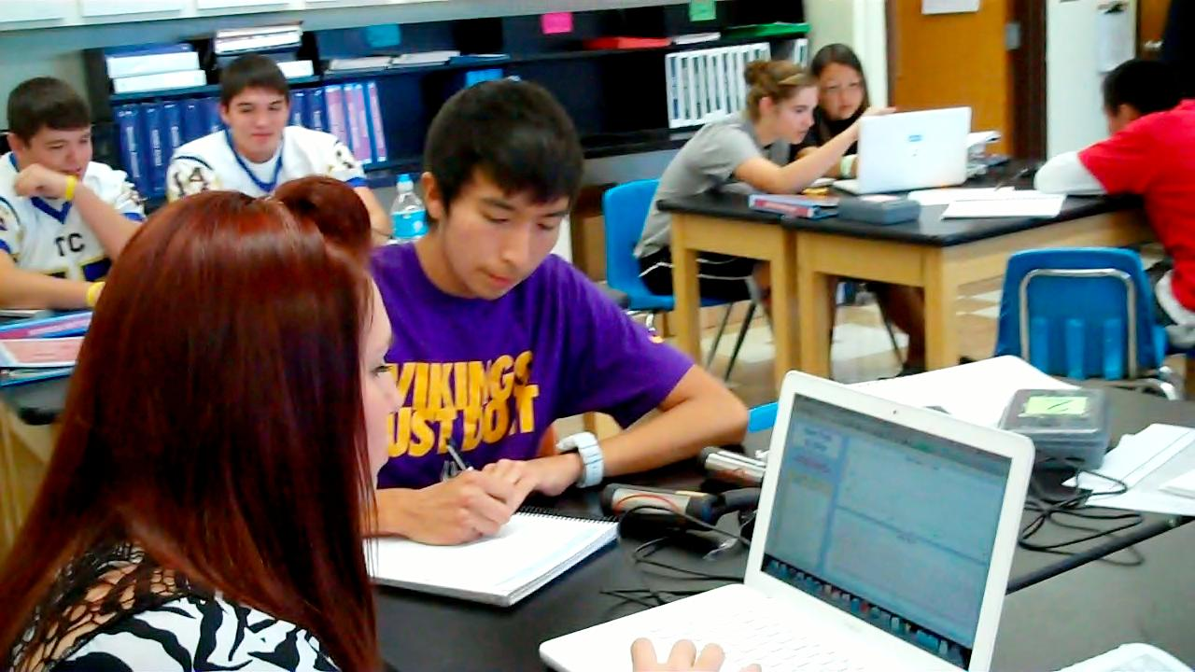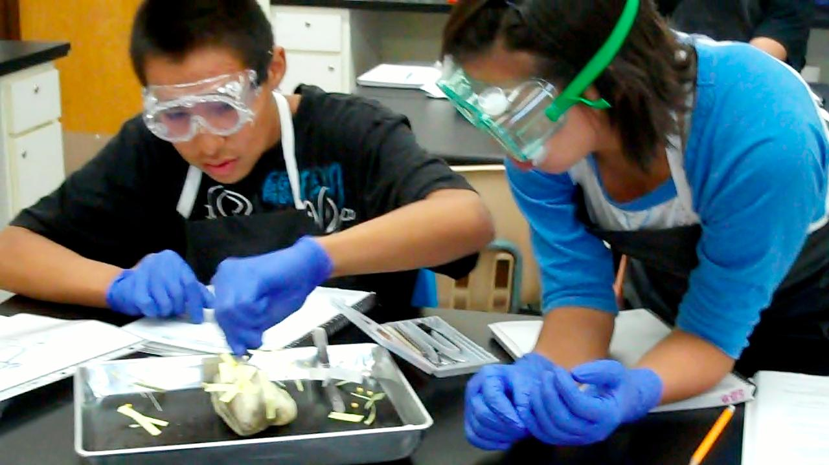**[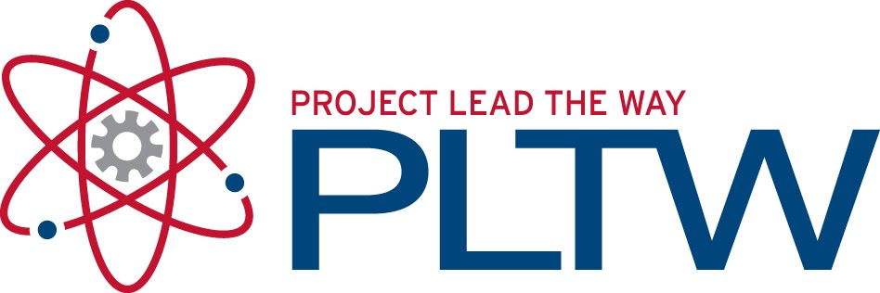](http://1.bp.blogspot.com/_IwrVxMXC70o/TGQDzOXeGzI/AAAAAAAAA2U/6TAzEaf3ywQ/s1600/PLTW.jpg)**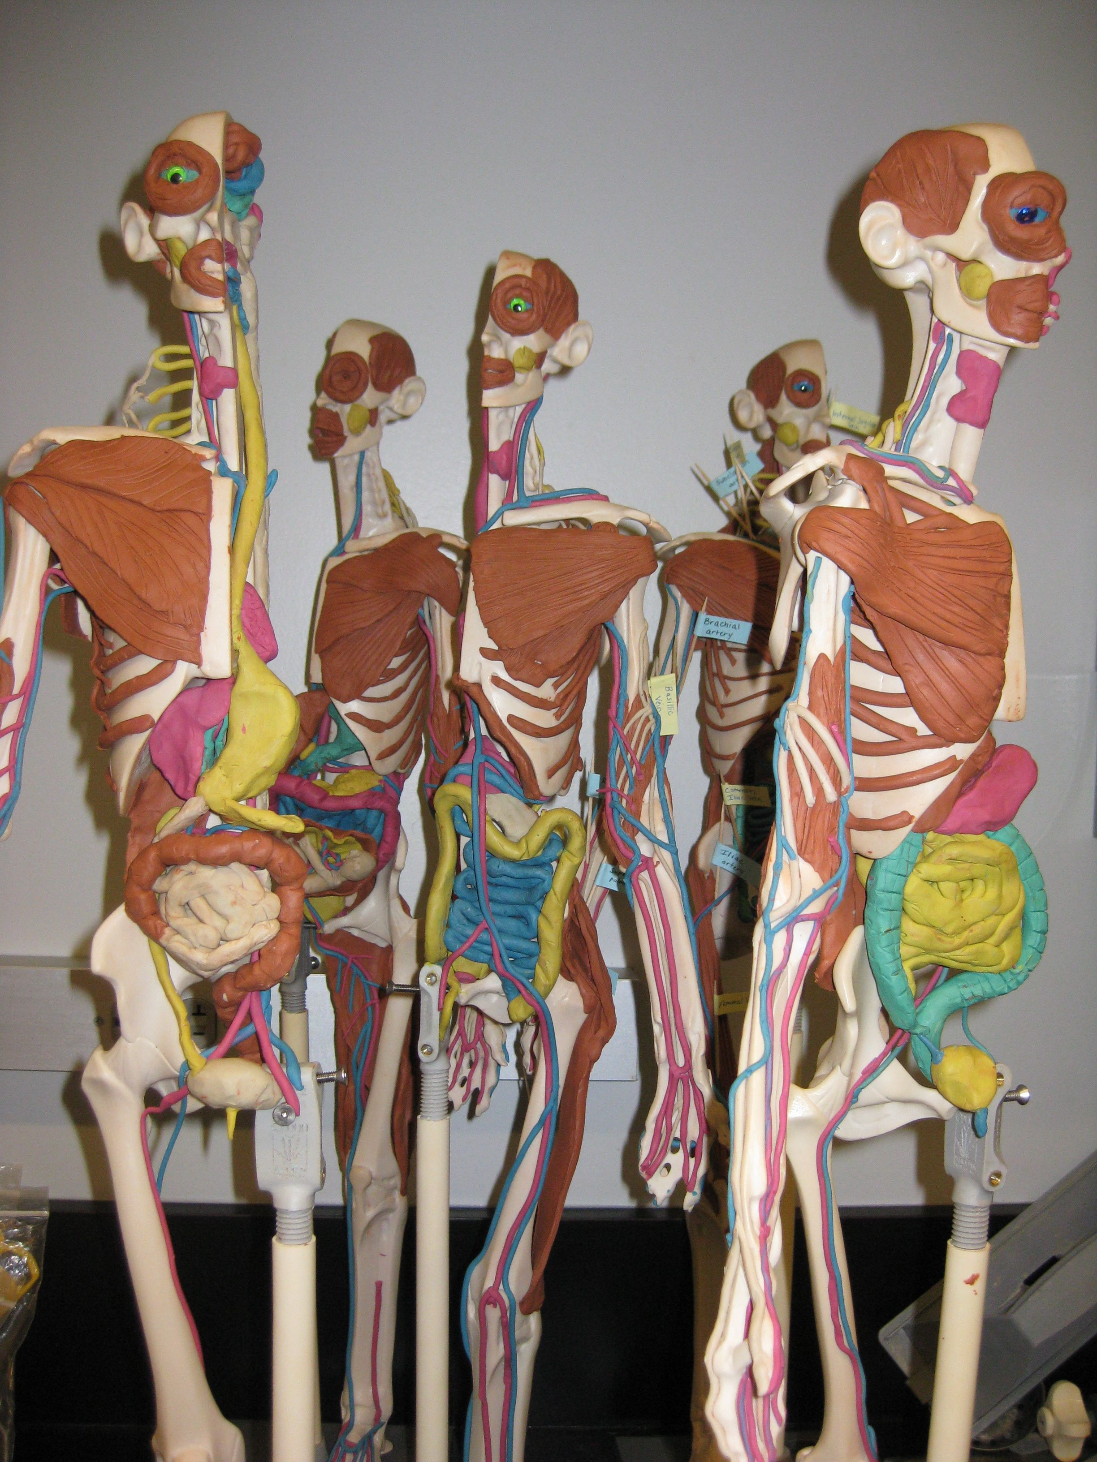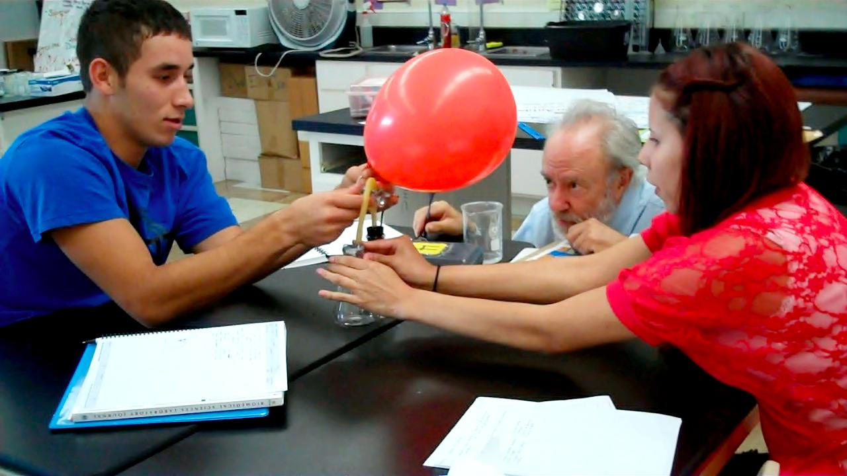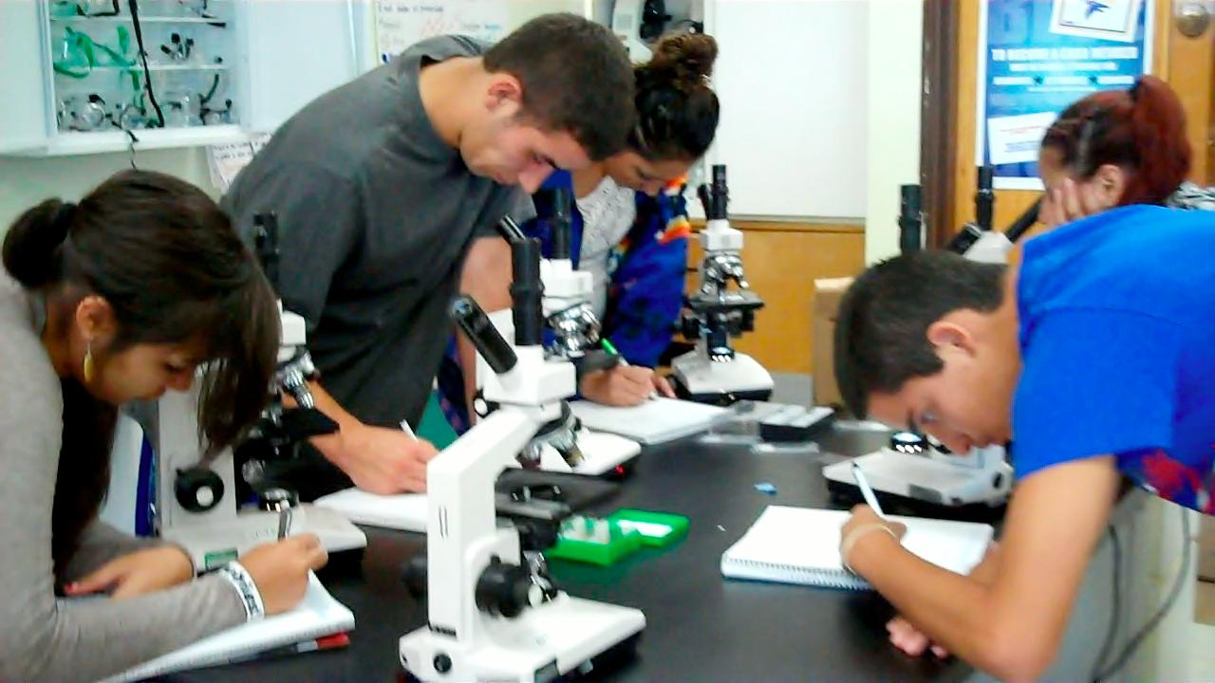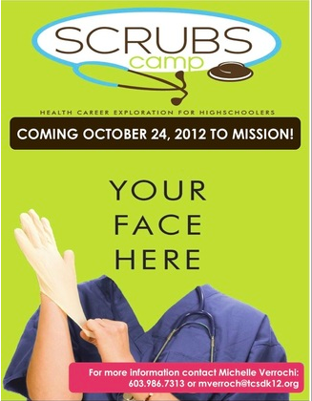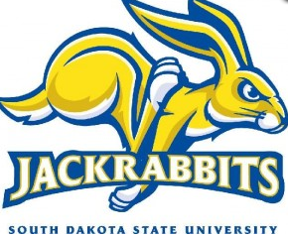

**Students work together to build a pump**

This month students have been designing experiments to see how exercise, body position, and external stimuli affect heart vital signs. Above, students use Vernier sensors and computer software to record vital signs including blood pressure, heart rate, and EKGs. Students also dissected sheep hearts.

Please feel free to contact me if you have questions or concerns. Also please reach out to me if would like to visit or be a guest speaker in the classroom.

E-mail: mverroch@tcsdk12.org

Phone: (603) 986-7313

Website:

http://toddcountyhs.weebly.com/pltw.html

To contact

Ms. Verrochi

## **Project Lead the Way is a national, educational program that assists high-school students in developing strong backgrounds in science.**

# Project Lead The Way at Todd County High School

Principles of Biomedical Sciences

Principles of Biomedical Sciences provides an introduction to the biomedical sciences through exciting hands-on projects and problems. The theme throughout the course is to determine the factors that led to the death of a fictional person. After determining the factors responsible for the death, the students investigate lifestyle choices and medical treatments that might have prolonged the person’s life. This class will be rigorous, challenging, fascinating, and fun. I expect that this class will motivate your child to work hard, help them learn to work well with others, and improve their higher-level thinking skills to be college and career ready.

###### Look for more publications!

**pg.1**

Volume 1 September 2012

Ms. Verrochi’s Class Newsletter

The second course of the program, Human Body Systems, uses Manikens ® in Clay in order to learn anatomy and physiology of the human body. In this course will work through interesting real world medical cases and often play the role of biomedical professionals to solve medical mysteries. Students will build manikins of the human body as investigate the structures and functions of body systems VERY cool stuff! This course will be available this spring for students who want to continue on in the PLTW program (college credit can be earned here too).

*Students must successfully pass PBS to enroll.

C

In unit 2 students have been practicing many lab skills necessary for health related fields. Students preformed dissections on pig hearts to apply their knowledge of the heart anatomy and forensic pathology. Students also learned how to measure and read heart vital signs and use problem solving skills to create pumps out of only the materials provided. In addition, students have been working with the microscopes to examine different tissues in the body and to learn about blood composition. The Biomedical Sciences program offers advantages to students including career readiness and hands-on experience. This college preparatory class is full with labs and creative exercises to prepares students to succeed in the classroom and in college. Students can also earn college credit if they score an 80% or higher on the ECA.

#### Students Learn Essential Laboratory Skills

**Principal Mr. Swartout looks on**

**as students build a pump**

**Students observing cardiac tissue**

**EVENTS/OPPORTUNITIES**

**SDSU Field Trip**  October 11th

The PBS class will travel to the Brookings campus to see a human cadaver lab and nursing simulation lab. In addition students will get to see what college life is like and enjoy lunch, which is hosted by the Native American Cultural Center.

**SCRUBS** **Camp** October 24th @ SGU

Free, one-day, hands-on health career camps for high school students. Students will have the opportunity to experience a wide variety of health careers through hands-on activities and discussions.  After the SCRUBS Camp, attendees will be eligible to apply for a field experience where they can shadow a health care professional of their choice.  This is the first year Mission will host a camp!

**Parent/Teacher Conferences** November 1st & 2nd

Thursday 1st – 12pm – 4pm

Friday 2nd – 8am – 12pm

It’s going to be a great semester!

**cont.**

Manikens ® for HBS

Justo id eleifend faucibus, urna dolor consectetuer dui, vel pretium risus purus sed pede. Integer diam elit, facilisis eget.

Donec varius, felis eget lobortis vehicula, magna sapien elementum tellus, ut iaculis dui orci sed arcu. Nullam semper leo.