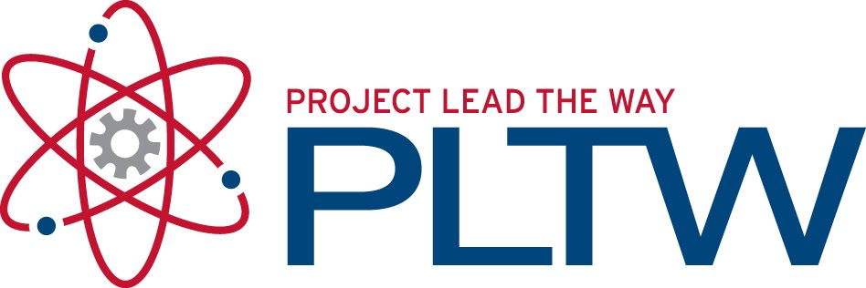

Medical Interventions

Instructor: Michelle Verrochi

School Address: Todd County High School, PO Box 726 • Mission, SD 57555

605-856-2324 • Room 214 • mverroch@tcsdk12.org

Webpage: http://toddcountyhs.weebly.com/pltw.html

COURSE INTRODUCTION AND SEQUENCE—What we’re going to learn and when

In this course will investigate the variety of interventions involved in the prevention, diagnosis and treatment of disease as you follow the lives of a fictitious family, the Smith’s.

PREREQUISITES: Principles of Biomedical Sciences and Human Body Systems

Fall Semester Topics
Unit One: How to Fight Infection  Lesson 1.1: The Mystery Infection  Lesson 1.2: Antibiotic Treatment  Lesson 1.3: The Aftermath: Hearing Loss  Lesson 1.4: Vaccination  Meet Sue Smith, the eighteen-year-old daughter of Mr. and Mrs. Smith. Sue is a college freshman who is presenting symptoms of an unknown infectious disease and is left with a hearing impairment. Through this case, you will explore the diagnostic process used to identify an unknown infection, the use of antibiotics as a treatment, how bacteria develop antibiotic resistance, how hearing impairment is assessed and treated, and how vaccinations are developed and used to prevent infection.  Unit 2: How to Screen What Is In Your Genes  Lesson 2.1: Genetic Testing and Screening  Lesson 2.2: Our Genetic Future  Meet Mr. and Mrs. Smith, who are expecting a new baby. Through this case, you will explore how to screen and evaluate the code in our DNA, the value of good prenatal care, and the future of genetic technology. | Unit Three: How to Conquer Cancer  Lesson 3.1: Detecting Cancer  Lesson 3.2: Reducing Cancer Risk  Lesson 3.3: Treating Cancer  Lesson 3.4: Building a Better Cancer Treatment  Meet Mike Smith, the sixteen-year-old son of Mr. and Mrs. Smith. Mike is diagnosed with osteosarcoma, a type of bone cancer that often affects teenagers. In order to remove all of the cancerous tissue, he had to have most of his arm amputated and he needs a prosthesis. Through this case, you will explore the diagnostic process used to determine the presence of cancerous cells, the risk factors and prevention of cancer, rehabilitation after disease or injury, and the design process for new medications, prosthetics, and nanotechnology.  Unit Four: How to Prevail When Organs Fail  Lesson 4.1: Manufacturing Human Proteins  Lesson 4.2: Organ Failure  Lesson 4.3: Transplant  Lesson 4.4: Building a Better Body  Meet Mrs. Jones, the forty-four-year-old sister of Mrs. Smith. Mrs. Jones has been struggling with Type 1 Diabetes Mellitus for twenty years. Mrs. Jones is now dealing with end stage renal failure and needs a kidney transplant. Through this case, you will explore protein production, blood sugar regulation, dialysis, organ donation and transplantation, non-invasive surgery techniques, as well as creation of a bionic human.
EARNING COLLEGE CREDIT
Students enrolled in this course will have the opportunity to earn biology college credits if they earn an 80% or better on the End-of-Course Assessment (ECA).

PLANNING FOR THE FUTURE
All students enrolled in this course are encouraged to take additional PLTW Biomedical Sciences courses in the future:
Class 4: Biomedical Innovation (spring 2013): Students design innovative solutions to topics in areas such as clinical medicine, physiology, biomedical engineering, and public health.

ORGANIZING FOR SUCCESS—Creating PLTW Portfolios

You will be keeping a portfolio of all the work you do throughout this program. You will be given guidelines on what are the components of this portfolio. This is an excellent tool for you to use at the end of this intense curriculum to showcase all the skills and knowledge you have gained. You will turn in the portfolio as a portion of your grade.

GRADING SCALE  100-90 A (Excellent)  89-80 B (Good)  79-70 C (Average)  69-60 D (Minimum Pass)  <60 F (Failing) | GRADE COMPONENTS—What you are graded on  Students will receive the greatest benefit from this class by attending on a regular basis, actively participating, & completing assignments.  Performance Grade (Tests, Quizzes, and Projects) 60%  Formative Grade (Portfolio, Classwork, and Homework) 40%

MAKE-UP POLICY

Students are responsible for completing makeup assignments in their notebooks within 1 week of the assigned date. Tutoring will be available to students after school on a weekly basis. There are retakes for quizzes or assessments. Students will be given opportunities to correct wrong answers and complete projects to share with the class to earn back points.

STANDARDS
Standards for this course are taken from National Science Education Standards, Principles and Standards for School Mathematics, National Health Care Cluster Foundation Standards, Standards for the English Language Arts, and Standards for Technology.

REFERENCES

This course was developed by Project Lead the Way, Inc. and all materials and information originated from their curriculum development. Only teachers who have received training by Project Lead the Way have permission to teach this course and use the materials.

COURSE GOALS—What you will get out of this class

Students will be able to demonstrate a thorough understanding of biology; furthermore, students will be able to practice 21st century skills to become better prepared for college of the work force. These skills include: collaborative, technologically savvy, good reader, problem solver, critical thinker, globally aware, communicator, and lifelong learner. The knowledge and skills students take from this class will prepare students for upper level science courses and for a wide variety of career aspirations.

ACADEMIC DISHONESTY—Knowledge is too precious to be stolen

Make sure everything complete for this class is your own work. Please make sure that you understand that even “group work” should be your own. Students caught cheating will receive no credit for the assignment.

I have HIGH EXPECTATIONS for all of you and am looking forward to an excellent year!!!

